**First and Ten**

August2014 Volume 8 Issue 7

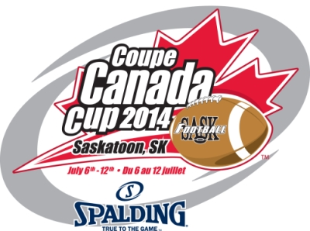



|  |  |
| --- | --- |
| **First and Ten Mandate** | 3 |
|  |  |
| **First and Ten Editors comments** | 4 |
| 2014 Canada Cup Report | 5 |
| **How to Design a Battery of Physical Fitness Tests** | 13 |
|  |  |
| **Physical Fitness testing for Elite Officials CFL style** | 15 |
| **Grip strength test** | 17 |
| **The Vertical Jump Test** | 18 |
| Sit & Reach Test | 19 |
| **The Beep Test** | 20 |
| Press Up Test | 21 |
| **The Crunch Test** | 22 |
| **40 yard dash** | 23 |
| **Defending the new defenseless player rule** By Daniel Nugent-Bowman, The Star phoenix July 12,20144 | 24 |
| Guidebook for NFL Hits: What's Legal, What's Not and What's Just Plain DirtyBy [Michael Schottey](http://bleacherreport.com/users/111184-michael-schottey), NFL National Lead Writer - Sep 4, 2013 | 27 |
| **What is a defenceless player RULE 7 SECTION 3 ARTICLE 16** | 32 |
| **Targeting” Defined in High School Football in Effort**  **to Reduce Risk of InjuryThis article is being re-published from the British Columbia Football Officials Association** | 33 |
| **Rule changes for 2014 What’s the call?** | 35 |
| Suggested answers | 39 |

**Working for the development of officiating and football in Canada in cooperation with**



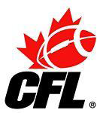

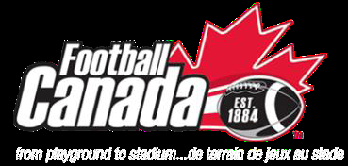

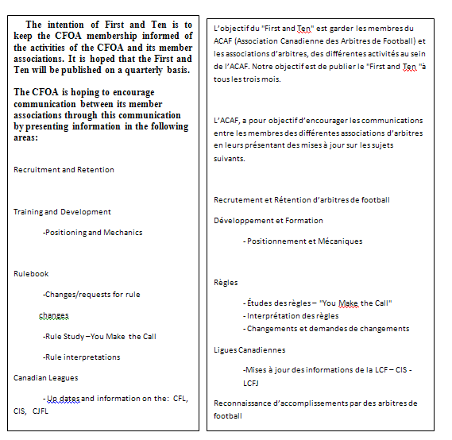

La version française du "First and Ten" va suivre chaque version anglaise. Ron Paluzzi, Vice président responsable de la traduction, sera responsable de s’assurer que chaque communiqué soit disponible en français dans les plus brefs délais. D’ici là, je demande à tous

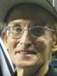

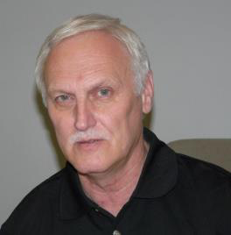

First and Ten Editor **Ron Hallock Co- editor Rob Christian**

**2014 Canada Cup Report**

Congratulations to the SFOA for hosting a successful tournament for all officials and supervisors. A review of the events that took place is presented. Feature presentation is the Physical Fitness testing for elite officials currently used by the CFL.

**Official Development Support**

In continuing to support the facilitator program, First and Ten continues to provide articles supporting Presenting, mentoring and self-development and evaluation. In this issue :

Defenceless player rule application is a major concern heading into the 2014, officials, coaches and players must understand the manner in which the rule is applied. An article written during the Canada Cup on the topic provides a segue into co-editor Rob Christian’ series of articles dealing with the defenceless player rule application

Rule Changes for 2104 review

Presented is a rules review presented to coaches to help bring attention to the rule changes and serve as means to lead to discussion this quiz was prepared b the MFOA VP recruitment and training Ardis Oleksyn



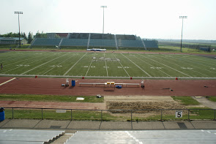The 2014 Football Canada Cup was played in Saskatoon, Saskatchewan at the University of Saskatchewan’s Griffith Field from July 6 to July 12. The tournament provided exciting football in every game. The teams, coaches, staff and managers should be commended for the effort they put into making this tournament a successful experience for all.

**Organization**

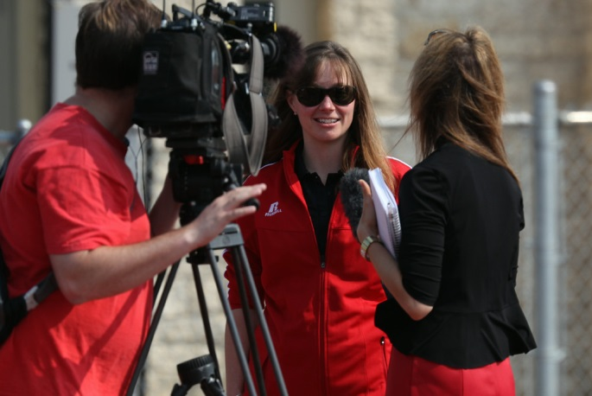The tournament was exceptionally organized and well run with leadership from **Football Canada’s** Shannon Donahue, Tamara Hinic and manger meetings Chair Robert St. Pierre FC governance committee

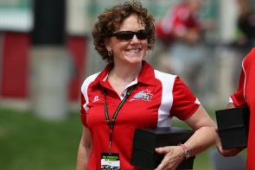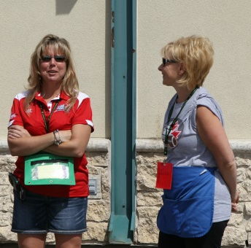The **Host Committee** lead by Andrea Eccleston and Cathy Sarich went out of their way to accommodate officials and meet the officials’ needs from meeting rooms, training facilities, dressing room requirements. They included officials in the opening ceremonies

The Official Organization Committee included organizer Todd Joyes and Murray Taylor local RIC.

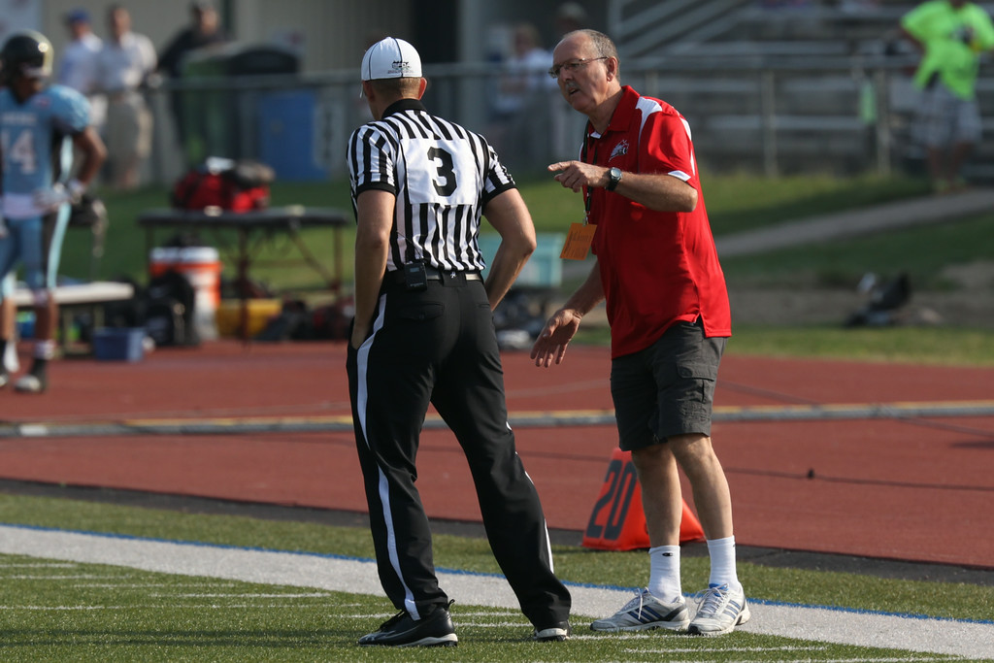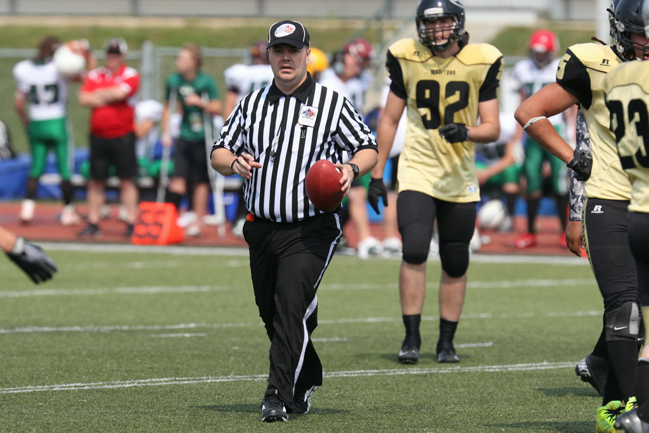A great job was done by Todd and his helpers in organizing the hospitality for all who participated in the weeks events.  
 Murray did an excellent job organizing local officials for on field, yardstick crews and timers and communicating assignments. Special thanks to timers, stick crews, ball boys and water boys’ excellent effort helped make the officiating crew operate efficiently

**Facilities**

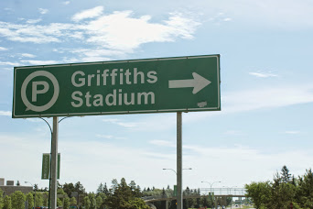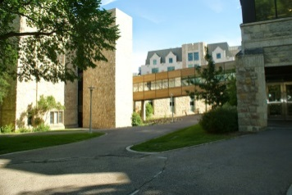Out of town officials were housed at the University of Saskatchewan residence Saskatchewan House. All meals were provided on campus.

The field and training facilities were excellent. Special acknowledgements to the Saskatchewan Huskies football team and coach Brian Towress for making their facilities available.

Dressing rooms were adequate and through the efforts of Todd Joyes, SFOA official event coordinator, were very professionally organized with name plates and clothing arranged for each official for their arrival.

In addition an additional adjoining room was provided for postgame meetings with crews so as not to interfere with the crew getting prepared for the next game.

**Officials and Official Game Appointments**

The tournament used seven official crews utilizing the eight out of town officials and supplementing them with selected officials from the SFOA. In round two efforts were made to not use out of town officials from the same province as the teams participating in games. In the final round the officials showing the best grading at their positions were selected for the championship games. Out of town officials did two games each round and all participated in either the gold or bronze medal games.

|  |  |  |  |  |
| --- | --- | --- | --- | --- |
| **Out of Town Officials** | | **SFOA officials** | **SFOA officials** | **Support crew** |
| **Rob Hendry-SK G** | | **Mike Ciona** | **Ryan Elder** | Worona |
| **Ryan Stark-SK W** | | **Perry Karakochuk** | **Support crew** | Cowton |
| **Brian Schouten-Ont** | | **Steve Chisholm** | LaLonde | Harbour |
| **Dan Senerchia-Que** | | **Duane Clark** | Leonard | Symchyck |
| **Vince Williams-NS** | | **JR Simpson** | Guidinger | Worona |
| **Patrick Fairweather-NB** | | **Sahne Carter** | LaFrance | Soloski |
| **Dan Mulvihill-Alta** | | **Walt Hawyrsh** | Seiferling | Ball boys |
| **Mike Hillman-Man** | | **Iain Cropper** | Cory | Timers |
|  | | **Todd Joyes** | Gray | Names were not available |
|  | | **John Stevenson** | McCormack |  |
|  | |
|  | |
|  |

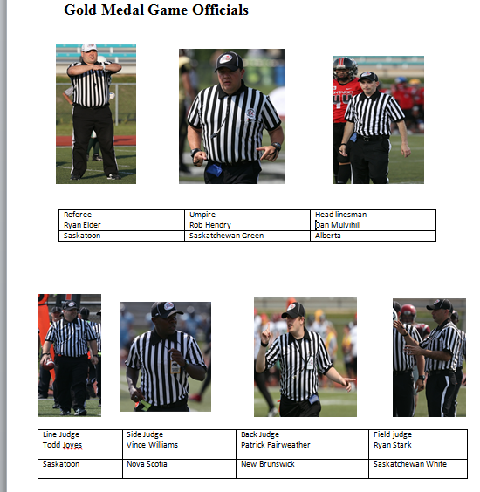

**Photo by Brian Schouten and Canada Cup photographer** smugmug website:  <http://u18canadacup2014.smugmug.com/Event-Photos/Volunteers-and-Officials/>

**Bronze Medal Game Officials**

|  |  |  |  |
| --- | --- | --- | --- |
| **Referee** | **Mike Ciona** | **Line Judge** | **Mike Hillman** |
| **Umpire** | **J.R. Simpson** | **Side Judge** | **Shane Carter** |
| **Field Judge** | **Iain Cropper** | **Back Judge** | **Brian Schouten** |
| **Head Linesman** | **Dan Senerchia** |  |  |

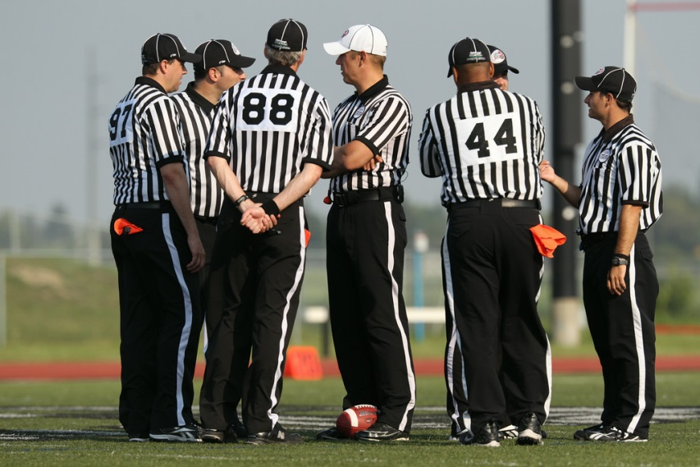

# C:\Users\rhallock\Pictures\cc\LC1_1718-XL.jpgC:\Users\rhallock\Pictures\cc\LC1_9057-XL.jpgC:\Users\rhallock\Pictures\cc\LC2_0341-XL.jpg

# http://u18canadacup2014.smugmug.com/Event-Photos/Volunteers-and-Officials/i-7H9LQkB/0/L/LC2_8935-L.jpg

# C:\Users\rhallock\Pictures\cc\LC1_0591-XL.jpghttps://lh3.googleusercontent.com/-8IfGKhNu--4/U8NVi3NGmgI/AAAAAAAANqY/xcMVECq1KYQ/w847-h567-no/DSC04036.JPGC:\Users\rhallock\Pictures\cc\LC2_7882-XL.jpg

# Game Supervision

# Game supervision was provide by a team of individuals with CFL,CIS and CJFL experience both on the field and now as game day supervisors. The team included Out of Province RIC Ron Hallock, Host RIC Murray Mitchell, CIS and CJFL supervisors Al Mitchell and Randy Warick (Saskatoon) and Robert St. Pierre (FC Governance Chair).

# Members participated in pre-game, half time and post-game meetings providing comments on officiating to help the development of the crews and individuals

# https://lh6.googleusercontent.com/-KIrkXwkRcKM/U8NRMAQgifI/AAAAAAAANhY/HaVvqE9hxfI/w847-h567-no/DSC03961.JPGhttp://u18canadacup2014.smugmug.com/Event-Photos/Volunteers-and-Officials/i-9cKR5qS/0/L/LC2_0234-L.jpg

# PhotoLeft Murray Taylor gives instructions to Referee Mike Ciona on the right Ron Hallock and Robert St. Pierre observing the games

# Photo

# http://www.saskatoonsportshalloffame.com/class/2010/randy_warick.jpgOff to give comments and suggestions at half time and after game

# Randy Warick and AL Mitchell Veteran officials and supervisors for CIS and CJFC also provided comments on officials

# PhotoSFOA Hospitality

# The hospitality provided by the SFOA was exceptional. Included were BBQs at get to know you event on the first night of arrival following on field seven official mechanics training session. A second BBQ, following the video sessions, was hosted by Murray Taylor and his wife at their residence. On an off day prior to the final round of the tournament the officials were taken out to nearby lake where they could participate in water sports or golf followed by a trip to a local casino. The tournament concluded with a Farewell Party following the final game.

# Photo

# C:\Users\rhallock\Pictures\DSC04204.JPGC:\Users\rhallock\Pictures\DSC04195.JPGC:\Users\rhallock\Pictures\DSC04201.JPG

# C:\Users\rhallock\Pictures\DSC04205.JPG

# Training Sessions

# Training sessions

Five major sessions were conducted for official development during the Canada Cup

Seven Official Mechanics Clinic

Upon arrival Friday, officials gathered at Griffith field for a two hour on field session and walk through for 7 official mechanics. The sessions were led by CFL official Tim Kroeker, CIS Supervisor Al Mitchell and Randy Warick a veteran CIS and CFL official

**Fitness Testing**

This session was made possible through the efforts of Todd Joyes, who organized and conducted the session

All out of town officials and members of the Saskatoon officials participated in the CFL officials’ fitness test. The test lasted half a day and included:

1. Identification of individual data:

Weight, height, BMI, body fat, muscle mass, waist and hip measurements

1. Physical tests included:

|  |  |  |  |
| --- | --- | --- | --- |
| 1 | Grip Strength | 5 | Crunches |
| 2 | Vertical Jump | 6 | Beep Test |
| 3 | Sit and Reach | 7 | Forty yard dash |
| 4 | Max push up (without stopping) |  |  |

**These Fitness tests are reproduced with references following this article for inspiring officials for want to design fitness programs for elite officiating development**

**Presentations by Ken Picot**

Ken Picot, former CFL official and current CFL game day supervisor in Regina as well as CIS and CJFL assignor and supervisor in Regina. Ken made three presentations on:

1. How to use Video for performance analysis
2. Understanding the Fitness test results
3. Visual Rule book situations in the End Zone

**Video sessions**

Following rounds 1 and 2 officials were provided the opportunity to review all games using the HUDL program prior to formal meetings. The officials then attended two four hour sessions where every game formally reviewed under the guidance of the RIC out of town.. Over 200 clips were reviewed for positioning, mechanics, and fouls called. Constructive comments were provided and officials had an opportunity to discuss and comment on the plays.

# PHYSICAL FITTNESSS TESTING FOR OFFICIALS

# A brief introduction of what type of physical testing a football official should do and why is presented followed by the CFL physical testing program

# 

**How to Design a Battery of Physical Fitness Tests**

[**http://www.sport-fitness-advisor.com/physical-fitness-tests.html**](http://www.sport-fitness-advisor.com/physical-fitness-tests.html)

|  |
| --- |
|  |

What exactly is a battery of physical fitness tests and how do you design one?

It is simply a group of fitness tests that **closely represents the various physiological demands of your sport or event**.

Step one is to break down the sport (or it could be an assessment for the Armed Forces or Fire Service) into its different fitness components. For an event such as the 100m sprint or the marathon this is fairly straight forward. Games such as basketball, rugby and volleyball for example are a little more complex.

One of the more complex examples is soccer. It's an intricate blend of aerobic and anaerobic endurance, strength, power, speed and agility. The test battery should include physical fitness tests that measure each of these components. But its not enough to simply test for strength or endurance per se...

Each test must replicate the energy demands **and** the movement patterns within the sport. Keeping with the soccer example for a moment:

Walking 1 mile as quickly as possible (Rockport test) is less sport-specific than running in 20m bursts backwards and forwards (Multistage shuttle run).

Once the precise energy and movement demands of the sport are understood, the most appropriate physical fitness tests can be chosen. In fact the athlete or coach can even make their own test up so long as it meets the following criteria...

### Sample Physical Fitness Tests

Here are some reliable physical fitness tests that measure strength, speed, power, endurance and flexibility. They require little or no equipment - or certainly equipment that is readily available to most people.

[**Strength Tests**](http://www.sport-fitness-advisor.com/strengthtests.html)   
**1) One repetition max** -- The standard strength test for all athletes.  
**2) Sit up test** -- A good indication of core strength.  
**3) Press up test** -- Used to test strength endurance.

[**Speed and Power Tests**](http://www.sport-fitness-advisor.com/powertests.html)   
**1) 30m sprint** -- A simple fitness test to measure power.  
**2) 30m sprint fatigue** -- Excellent for multisprint sports such as basketball, soccer, hockey etc.  
**3) Illinois agility test** -- Another great fitness test for multisprint sports.  
**4) Standing long jump** -- A simple test to measure explosive, ultra-short term power  
**5) Standing Vertical jump** -- The standard fitness test used to measure explosive power. Particularly relevant to basketball and volleyball.  
**6) Hexagon drill** -- Excellent test to measure quickness, agility and balance.

[**Endurance Tests**](http://www.sport-fitness-advisor.com/endurancetests.html)   
**1) Balke 15 minute run** -- A fitness test to measure aerobic power (VO2max) indirectly.  
**2) Cooper 12 minute run** -- As above  
**3) Multistage shuttle run** -- Also used to estimate aerobic power but more appropriate for multisprint sports. Also effective for testing large groups at a time.  
**4) Rockport test** -- A simple walking test for less active individuals.

[**Flexibility Tests**](http://www.sport-fitness-advisor.com/flexibilitytests.html)   
There are only a few reliable tests to measure flexibility. The best instrument is a **goniometer** (a very simple and cheap type of protractor). It can be used to measure the flexibility of most joints and the range of motion for dozens of movements.  
**1) Sit and reach test** -- The standard flexibility test that measures lower back and hamstring flexibility.  
**2) trunk rotation test**  
**3) Groin flexibility test**

### Test Order

According to the NSCA (1) a battery of physical fitness test should occur in the following order:

1. Non-fatiguing tests (height/weight measurements, skinfolds, vertical and broad jumps)  
2. Agility tests (T-test, Illinois test)  
3. Maximal strength & power tests (1-RM, 3-RM)  
4. Sprint tests (40yard sprint, sprint fatigue test)  
5. Muscular endurance tests (12min run, shuttle test)

### An Example Battery Of Physical Fitness Tests

Here's an idea for a test battery for our soccer example...

|  |  |  |  |
| --- | --- | --- | --- |
| **Example Test Battery For Soccer** | | | |
| **Test number** | **Test** | **Fitness component** | Time (mins) |
| 1 | Skinfold measurements | Body composition | 20 |
| 2 | Standing jump test | Explosive power | 10 |
| 3 | 30 meter sprint test | Short term power | 10 |
| 4 | Sprint fatigue test | Power maintenance | 10 |
| 5 | 1-RM test | Maximal strength | 15 |
| 6 | Press up test | Muscular endurance | 5 |
| 7 | Sit up test | Muscular endurance | 5 |
| 8 | Multistage shuttle run | Aerobic endurance | 20 |
| 9 | Sit and reach test | Flexibility | 5 |
| 10 | Groin flexibility test | Groin flexibility | 5 |

Now that you have developed your battery of physical fitness tests, use it at the **beginning** of your training program (usually the start of pre-season training. Use precisely the same set of tests to measure yourself about 6 weeks later and note your progress. It's a good idea to test yourself just **prior** to the start of the competitive season and then a couple of times **during** the competitive season.



# The following CFL physical fitness program was taken by officials participating in the Canada Cup to see what level Elite officials must achieve in order to participate in elite levels

# Grip Strength Test

### Objective

To monitor the development of the athlete's grip strength.

|  |  |  |  |
| --- | --- | --- | --- |
| Top of Form  Bottom of Form | Testing and measurement are the means of collecting information upon which subsequent [performance evaluations and decisions are made](http://www.brianmac.co.uk/eval.htm#benefits) but in the analysis we need to bear in mind the [factors that may influence the results](http://www.brianmac.co.uk/eval.htm#effect). Objective To monitor the development of the athlete's grip strength. Required Resources To undertake this test you will require:   * Dynamometer * Assistant  |  |  | | --- | --- | | How to conduct the test  * The athlete using their dominant hand applies as much grip pressure as possible on the dynamometer * The assistant records the maximum reading (kg) * The athlete repeats the test 3 times * The assistant uses the highest recorded value to assess the athlete’s performance | Dynamometer | |

**Video link** [**http://www.youtube.com/watch?v=aRPs3kW5j\_c**](http://www.youtube.com/watch?v=aRPs3kW5j_c)



**The Vertical Jump Test**

The Sargent Jump Test (Sargent 1921)[[7]](http://www.brianmac.co.uk/sgtjump.htm" \l "ref), also known as the vertical jump test, was developed by Dr. Dudley Allen Sargent (1849-1924). <http://www.brianmac.co.uk/sgtjump.htm>

### Objective

To monitor the development of the athlete's elastic leg strength.

### Required Resources

|  |  |  |
| --- | --- | --- |
| Start | Mid | End |

To undertake this test you will require:

* Wall
* Tape measure
* Step Ladder
* Chalk
* Assistant

### How to conduct the test

* The athlete [warms up](http://www.brianmac.co.uk/warmup.htm) for 10 minutes
* The athlete chalks the end of his/her finger tips
* The athlete stands side onto the wall, keeping both feet remaining on the ground, reaches up as high as possible with one hand and marks the wall with the tips of the fingers (M1)
* The athlete from a static position jumps as high as possible and marks the wall with the chalk on his fingers (M2)
* The assistant measures and records the distance between M1 and M2
* The athlete repeats the test 3 times
* The assistant calculates the average of the  recorded distances and uses this value  to assess the athlete’s performance

Top of Form

Bottom of Form

# Sit & Reach Test

<http://www.brianmac.co.uk/sitreach.htm>

Testing and measurement are the means of collecting information upon which subsequent [performance evaluations and decisions are made](http://www.brianmac.co.uk/eval.htm#benefits) but in the analysis we need to bear in mind the [factors that may influence the results](http://www.brianmac.co.uk/eval.htm#effect).

### Objective

The objective of this test is to monitor the development of the athlete's lower back and hamstring flexibility.

### Sit and ReachRequired Resources

To undertake this test you will require:

* Box
* Metre Ruler
* Tape
* Assistant

### How to conduct the test

|  |  |
| --- | --- |
| * The athlete [warms up](http://www.brianmac.co.uk/warmup.htm) for 10 minutes and then removes their shoes * The assistant secures the ruler to the box top with the tape so that the front edge of the box lines up with the 15cm (6 inches) mark on the ruler and the zero end of the ruler points towards the athlete * The athlete sits on the floor with their legs fully extended with the bottom of their bare feet against the box * The athlete places one hand on top of the other, slowly bends forward and reaches along the top of the ruler as far as possible holding the stretch for two seconds * The assistant records the distance reached by the athlete’s finger tips (cm) * The athlete performs the test three times   Video link <http://www.youtube.com/watch?v=lv-_D8NnKdw> |  |

**The Beep Test**

---------------------------------------------------------------------------

<http://www.thebeeptest.com/beeptest1.html>

The beep test, also known as the bleep test, multi-stage fitness test, or shuttle run test, is used by sports coaches and trainers to estimate an athlete's maximum oxygen uptake better known as VO2 Max. The test is especially useful for players of sports like football, hockey, or rugby. The test involves running continuously between two points that are 20metres apart. These runs are synchronised with a pre-recorded audio tape, CD or laptop which plays beeps at set intervals. As the test proceeds, the interval between each successive beep reduces, forcing the athlete to increase velocity over the course of the test, until it is impossible to keep in sync with the recording.

The recording is typically structured into 23 'levels', each of which lasts 60 seconds. Usually, the interval of beeps is calculated require a speed at the start of 8.5 km/h, which increases by 0.5 km/h with each level. The progression from one level to the next is signalled by 3 rapid beeps. The highest level attained before failing to keep up is recorded as the score for that test.

The procedure is designed to measure the maximum endurance of an individual. Therefore, it should not be used for those of low fitness levels.

This test is now used by the British Army as one of the basic measures of personal fitness.

Video link

<http://www.youtube.com/watch?v=weEe4V0Ot2Y>

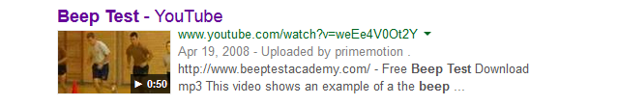

There are many free downloads available on you tube

# Press Up Test

### Objective

### The objective of the Press Up test is to assess the strength endurance of the athlete's upper body muscles. Required Resources

To undertake this test you will require:

* Non-slip surface
* Assistant

|  |  |
| --- | --- |
| How to conduct the test  * The athlete [warms up](http://www.brianmac.co.uk/warmup.htm) for 10 minutes * The athlete lies on the ground, places their hands by the shoulders and straightens the  arms - see Figure 1 (start position) * The athlete lowers the body until the elbows reach 90° (see Figure 2) and then extends the arms to return to the start position * The athlete continuous this press-up action, with no rest, until they are unable to continue * The assistant counts and records the number of correctly completed press-ups | Press up Figure 1  Press up Figure 2 |

|  |  |
| --- | --- |
| Athletes with less relative strength in the upper body can use the modified press up position to assess their upper body strength.   * The athlete [warms up](http://www.brianmac.co.uk/warmup.htm) for 10 minutes * The athlete lies on the ground, places their hands by the shoulders, straightens the  arms and keeps the knees on the ground- see Figure 3 (start position) * The athlete lowers the body until the elbows reach 90° - see Figure 4 and then extends the arms to return to the start position * The athlete continuous this press-up action, with no rest, until they are unable to continue * The assistant counts and records the number of correctly completed press-ups | Press Up Figure 3  Press up Figure 4 |

The Crunch Test

**The Crunch Test**, technically referred to as the "partial curl-up" test, measures **abdominal strength and endurance**, a combination that more truly reflects your fitness level than strength tests alone. This test is a better choice over the standard sit-ups because crunches are safer for the lower back and target the abs better. A timed crunch test can also be done anywhere.  
  
**Equipment needed:** A stop watch or timer that can measure one full minute; a ruler; a friend to help keep count and time you (optional).  
  
**Goal:** Do as many crunches as you can in one minute.  
  
**Execution:** Although this test involves regular [crunches](http://www.sparkpeople.com/resource/exercises.asp?exercise=2), it has some specific guidelines. Lie down on your back with your knees bent, feet flat on the floor and your heels about 18 inches away from your behind. Place your arms at your sides, palms down, fingertips next to your hips. Place a ruler next to your fingertips in this position and measure 6 inches further. You can put a piece of paper, the ruler itself, or a piece of tape at that 6-inch marker.  
  
Keep your hands on the floor throughout the test. Just like abdominal crunches, engage the abs to lift your head, neck, and shoulder blades off the floor, but allow your fingertips to slide toward the 6-inch marker. Return to the starting position to complete one rep. Repeat this as many times as you can in 60 seconds, counting only the number of repetitions that your fingertips successfully reach the 6-inch marker. You may rest in the starting position (relaxed), but the clock continues to run.  
  
**What this measures:** Strength and endurance in your abdominals.  
  
**Scoring:** Here are the age-adjusted standards based on guidelines published by the American College of Sports Medicine (ACSM):  
  
**Ratings for Men, Based on Age**

|  |  |  |  |
| --- | --- | --- | --- |
| **Rating** | **< 35 years** | **35-44 years** | **> 45 years** |
| **Excellent** | **60** | **50** | **40** |
| **Good** | **45** | **40** | **25** |
| **Marginal** | **30** | **25** | **15** |
| **Needs Work** | **15** | **10** | **5** |

Video link <http://www.youtube.com/watch?v=coX-FAPzpVo>

# 40 Yard Dash

Sprint or speed tests can be performed over varying distances, depending on the factors being tested and the relevance to the sport. The 40 Yard (36.6 meters) Dash is part of the [SPARQ rating system for football](http://www.topendsports.com/sport/gridiron/football-sparq.htm), and their protocol is listed here.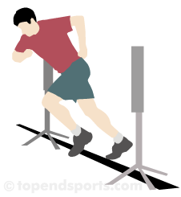

* **purpose:** The aim of this test is to determine acceleration, and also a reliable indicator of speed, agility and quickness.
* **equipment required:** [measuring tape](http://www.topendsports.com/resources/stores.htm?node=30&cat=Tape%20Measures) or marked track, [stopwatch](http://www.topendsports.com/resources/stores.htm?node=28&cat=Stopwatches) or [timing gates](http://www.topendsports.com/testing/timing-gates.htm), [cone markers](http://www.topendsports.com/resources/stores.htm?node=29&cat=Cones), flat and unobstructed grass, track, or turf surface of at least 60 yards.
* **procedure:** The test involves running a single maximum sprint over 40 yards, with the time recorded. A thorough warm up should be given, including some practice starts and accelerations. Start from a comfortable stationary 3-point stance position, a position that is most familiar to you and that you think will yield the best time. The front foot must be on or behind the starting line. This starting position should be held for 3 seconds prior to starting, you may lean across the starting line, and no rocking movements are allowed. The tester should provide hints to maximizing speed and encouragement to continue running hard past the finish line. See video examples of the [Sprint Tests](http://www.topendsports.com/videos/testing/speed/).

|  |  |
| --- | --- |
| **40 yard Sprint Scores  (general guidelines)** | |
| College Footballers | 4.6 - 4.9 secs |
| High School Footballers | 4.9 - 5.6 secs |
| Recreational College athletes (male) | ~5.0 secs |

* **results:** Two trials are allowed, and the best time is recorded to the nearest 2 decimal places. The timing starts from the first movement (if using a stopwatch) or when the timing system is triggered, and finishes when the chest crosses the finish line and/or the finishing timing gate is triggered

# Question of Defenceless player and how the rule is applied

**Defending the new defenseless player rule**

By Daniel Nugent-Bowman, The Star phoenix July 12, 2014

<http://www.thestarphoenix.com/sports/defending+defenceless+player+rule/10024656/story.html>)

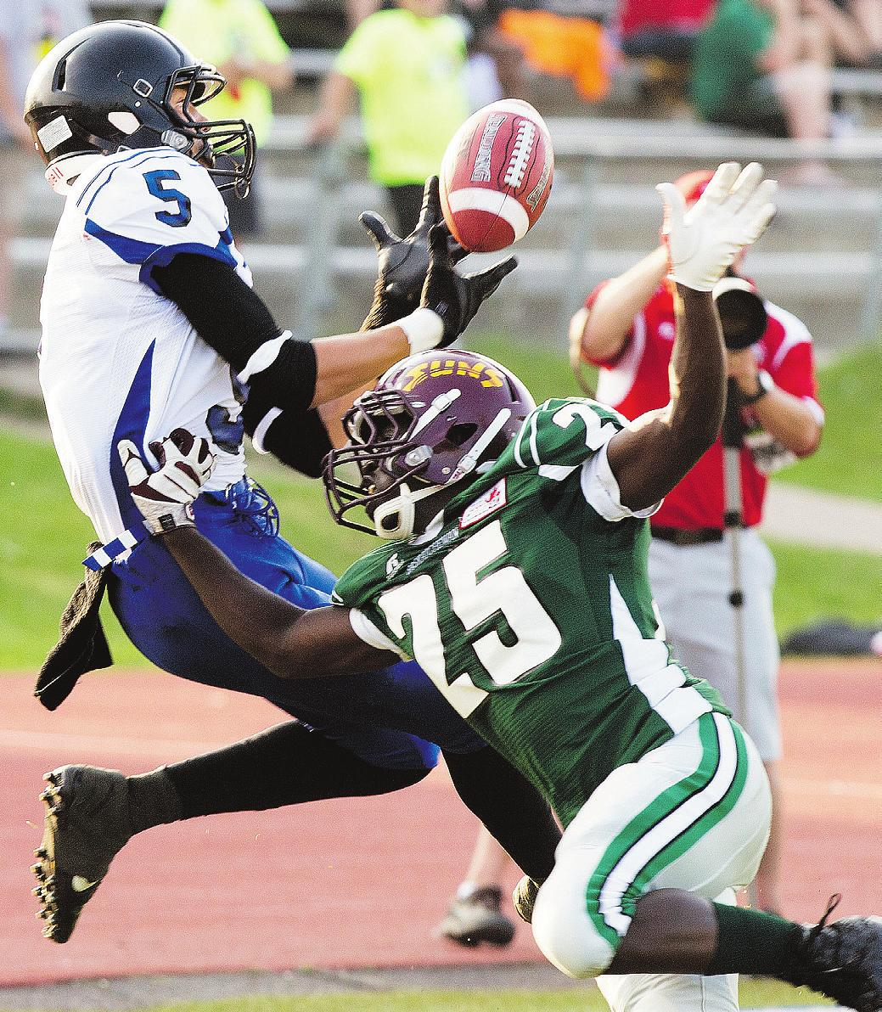

**Polis Koko of Team Saskatchewan Green, right, breaks up a pass attempt to Trey Kellogg of Team Alberta in Canada Cup football action Wednesday at Griffiths Stadium in Saskatoon. Photograph by: Greg Pender, The Star phoenix , The Star phoenix**

Expectations are high that Football Canada rule changes to make the sport safer will have a desired effect.

However, those at the Canada Cup under-18 tournament believe the learning curve has been - and will be - steep for officials, coaches and players.

"We haven't had a lot of time to digest these rules," said Todd Joyes, the Saskatchewan representative for the Canadian Football Officials Association and the Canada Cup officials' director. "There is a little bit of interpretation that still needs to be done."

Football Canada's tackle rules committee instituted changes to 15 articles in its rule book in May.

The Canada Cup is one of the early events where those rules have been implemented.

Most of the alterations were made to decrease the chances of players suffering concussions - a problem prevalent in contact sports.

The biggest addition is Rule 7, Section 3, Article 16 - player in a defenceless posture.

The rule makes it illegal to hit a quarterback, receiver, punt receiver or unsuspecting player while blocking. While the spirit of the rule is to discourage defenders from launching themselves at the offensive player or leading to hit them with their helmet, it is open to interpretation.

"We're really kind of figuring it out right now," Football Saskatchewan executive director Jeff Yausie said before praising the rule changes. "Even the officials are figuring it out.

"I've talked to some officials. It's being called in different ways right now. That's the reality."

Yausie believes it could take up to a full year for everyone to be on the same page.

Until then, Yausie, the defensive co-ordinator and linebackers coach for the Canadian Junior Football League's Saskatoon Hilltops, may have to change what he asks of his players.

"It may be a decision where we're going to have to get them to play the ball more instead of playing the man," he said. "In our old adage, you talk about if you play the man you're always safe.

"If he catches the ball, you can tackle him. If you miss the ball, he's gone for a big play. There will be a learning curve."

One of the most glaring examples of that rule being called at the Canada Cup was in Wednesday's game between Saskatchewan Green and Alberta.

Alberta defensive back Tony Savchuk hit Saskatchewan's Jamal Hooker in the flats as Hooker jumped up to catch a pass from quarterback Sawyer Buettner.

Savchuk was flagged for unnecessary roughness of a defenceless receiver and Saskatchewan, which had its drive prolonged, scored shortly thereafter.

"We do want to err on the side of caution, 100 per cent," Joyes said. "We don't want any injuries. We will give a bit of the benefit of the doubt to the person that's getting hit.

"However, we don't want to be throwing flags on every play."

Joyes said referees have been putting in the time to ensure the correct calls are made.

He estimates that they've watched 36 hours of game film for the eight games played to date.

Five evaluators meet with officials before each game. The evaluators then watch the game and provide a report to the referees at halftime and following the game.

Ron Hallock, the Canada Cup referee-in-chief from out of town, is pleased with their work.

"A team gave us seven clips to look at," said Hallock, also the chairman of both the Football Canada officials' development committee and the rules committee.

"The officials were correct on six. They only missed a no-yards call."

Saskatchewan Green general manager Mike Humenny admits the change in philosophy is still a work in progress for the coaches and the players.

However, it is necessary one, he said.

"Before we've seen those types of plays where after a catch there is a big hit or collision that's sometimes used as a motivational technique for a team," said Humenny, who also coaches high school football in North Battleford. "If that happens and all of the sudden they're flagged for it and the ball goes to the one-yard line, those are momentum swings in the opposite way.

"As coaches, we're going to have to sit down with the players and educate them."

While that education process still needs some ironing out, there is one basic thing for everyone to consider when judging a hit: It all comes down to safety.

"It has to be near the point of attack," Hallock said. "It can't be from far away.

"That's what it is. The first thing you ask is, 'was it necessary?'" dnugent-bowman@thestarphoenix.com Twitter.com/DNBsports

© Copyright (c) The StarPhoenix

# Facilitator: Official Development : Understanding Rules

# This article was released in 2013. The emphasis on both sides of the border is a substantial reduction in “targeting and hitting a player in a defenceless posture”. High school football in the US will also be implementing these rules in 2014 (*see article below*).

# Rob Christian

# A Guidebook for NFL Hits: What's Legal, What's Not and

# What's Just Plain Dirty

By [Michael Schottey](http://bleacherreport.com/users/111184-michael-schottey), NFL National Lead Writer - Sep 4, 2013

#### *video:* [*A Guidebook for NFL Hits.doc*](A%20Guidebook%20for%20NFL%20Hits.doc)

#### 

For the past couple of seasons, the National Football League has been trying to make the game of football safer—at least, if one believes the [NFL](http://bleacherreport.com/nfl)'s side of the story.

Commissioner Roger Goodell has become known as the judge, jury and executioner of player punishment as he has presided over an increase in fines having to do with player safety. In a way, Goodell and the owners have tried to legislate safety into an intrinsically unsafe game.

This, of course, happened at the same time as a [now-settled lawsuit](http://www.usatoday.com/story/sports/nfl/2013/08/29/nfl-concussion-settlement-judge-anita-brody-tony-dorsett-jim-mcmahon-junior-seau/2727483/) by thousands of former players who attested that the NFL purposefully deceived them on the long-term dangers of concussions and head trauma in pro football was being contested by the league.

If nothing else, the renewed focus on safety has given the league something to highlight on the legal telestrator.

The "new" rules stem from before the 2011 season, when the NFL decided to protect what it considers defenceless players. At that time, Ray Anderson—who serves as the NFL's executive vice president of football operations—[told CBS Sports:](http://www.cbssports.com/nfl/story/14820180/nfl-proposes-new-rules-suspensions-for-illegal-hits/rss)

Rules defining a defenseless player were expanded to include eight categories:

* A quarterback in the act of throwing;
* A receiver trying to catch a pass;
* A runner already in the grasp of tacklers and having his forward progress stopped;
* A player fielding a punt or a kickoff;
* A kicker or punter during the kick;
* A quarterback at any time after change of possession;
* A receiver who receives a blind-side block;
* A player already on the ground.

This year, the NFL is adding yet another wrinkle to the rulebook, outlawing offensive players from lowering the [crowns of their helmets](http://sportsillustrated.cnn.com/nfl/news/20130320/nfl-helmet-rule-change/) to ward off defensive players.

For someone who grew up in the "golden era" of football, watching guys like San Francisco 49ers safety Ronnie Lott or Chicago Bears linebacker Mike Singletary dishing out hits, it's easy to question whether the "good ol' days" have come and gone.

Yet, it's more than a little quixotic to pretend as if the NFL is losing any followers as a result of its attempt to protect its players. It may make some die-hards pine for "better" days, but it's also coincided with the best TV ratings and fastest-rising TV dollars in the sport's history. A purist might try to argue that the integrity and passion of the game is more important than money, but I don't think the NFL owners are listening.

Quibble with the intent and necessity of the rules all you'd like (there's a great comment section below), but this column is intended to fix one of my pet peeves. Rules are rules, and the players know the rules—or, at least, they should. Fans, on the other hand, rarely see the black and white of that matter, preferring to see the world in shades of gray with highlights of their favourite team's colors.

As Week 1 starts and the season begins, here is what illegal hits look like in the NFL rulebook.

**Illegal Hits on Quarterbacks**

OK, we all understand "roughing the passer," correct? But, did you know that roughing the passer accounts for an entire page in the NFL rulebook? In addition to hitting the quarterback after he has already thrown the ball, the rule encompasses: lunging at his knees, clubbing at his throwing hand and unnecessarily throwing him down with excess force.

Also from the rulebook under roughing the passer:

A defensive player must not use his helmet against a passer who is in a defenseless posture—for example, (1) forcibly hitting the passer’s head or neck area with the helmet or facemask, even if the initial contact of the defender’s helmet or facemask is lower than the passer’s neck, and regardless of whether the defensive player also uses his arms to tackle the passer by encircling or grasping him; or (2) lowering the head and making forcible contact with the top/crown or forehead/"hairline" parts of the helmet against any part of the passer’s body. This rule does not prohibit incidental contact by the mask or non-crown parts of the helmet in the course of a conventional tackle on a passer.

*"Frankly, now that the notice has been given, players and coaches and clubs are very aware of what the emphasis is and we won't have that hesitation. Everyone will be very clearly on notice now that a suspension is very viable for us and we will exercise it ... when it comes to illegal hits to the head and neck area and to defenceless players..."*

When tackling a passer who is in a defenseless posture (e.g., during or just after throwing a pass), a defensive player must not unnecessarily or violently throw him down and land on top of him with all or most of the defender’s weight. Instead, the defensive player must strive to wrap up the passer with the defensive player’s arms.

At least, that is what referees are looking for. Does it get called properly every time? Of course not, so that's what fans and media should hold them accountable for.

**Illegal Hits on Backs and Receivers**

Running backs are the least protected players in all of football. While running the ball, it's assumed that high-speed collisions are going to be part of the equation. That said, there are still some rules for defenders to follow.

First, tripping is normally something we expect to be called on offensive players tripping up defenders (similar to the leg-whip call), but a defender on the ground who attempts to trip up a runner rather than tackle him could be called for a penalty—even if that's what we would logically expect the defender to do.

There is also hitting a runner while he is out of bounds. This is often viewed as more of a judgement call by the refs when it really isn't. The NFL rulebook clearly puts the onus on defensive players in these instances:

Defensive players must make an effort to avoid contact. Players on defense are responsible for knowing when a runner has crossed the boundary line, except in doubtful cases where he might step on a boundary line and continue parallel with it.

That's pretty clear, and gives far less benefit of the doubt than many fans would probably like.

Then, we get to the aforementioned section of the rulebook. This prohibits any hits to the head of the runner or by the head of the defender on runners who do not have the ability to defend themselves and/or are not in a defensive posture.

Again, the burden of proof is placed on defensive players:

A player who initiates contact against a defenceless opponent is responsible for avoiding an illegal act. This includes illegal contact that may occur during the process of attempting to dislodge the ball from an opponent. A standard of strict liability applies for any contact against a defenceless opponent, even if the opponent is an airborne player who is returning to the ground or whose body position is otherwise in motion, and irrespective of any acts by the defensel Frankly, now that the notice has been given, players and coaches and clubs are very aware of what the emphasis is and we won't have that hesitation. Everyone will be very clearly on notice now that a suspension is very viable for us and we will exercise it ... when it comes to illegal hits to the head and neck area and to defenseless players... ess opponent, such as ducking his head or curling up his body in anticipation of contact. Frankly, now that the notice has been given, players and coaches and clubs are very aware of what the emphasis is and we won't have that hesitation. Everyone will be very clearly on notice now that a suspension is very viable for us and we will exercise it ... when it comes to illegal hits to the head and neck area and to defenseless players...

Consider this hit by Chicago Bears linebacker Jon Bostic:

It was, at first, heralded by just about everyone as a great play by the rookie linebacker. Then, Bostic received his fine letter via FedEx and the NFL had to go [around explaining](http://www.cbssports.com/nfl/eye-on-football/23285068/nfl-explains-why-jon-bostics-hit-is-illegal-and-dj-swearingers-isnt) exactly why it was illegal.

Again, it's a bang-bang play, and exactly the kind of effort and tenacity that coaches want to see, but the rulebook says that Bostic has to make sure that he's not leading with his helmet.

**Illegal Hits on Specialists**

Alongside the rarely called penalty of sliding under the kicker or punter in order to prevent him from returning to the ground, most roughing-the-kicker or roughing-the-punter penalties occur because the defender has initiated contact with either the kicking leg or the plant leg of the specialist.

There are some well-known caveats, however: A defender can be blocked into the specialist, and the specialist can be held accountable for attempting to "draw" the foul by his own actions. Also, if the specialist attempts to run in any way—even to attempt a rugby-style kick or "quick kick"—he's fair game.

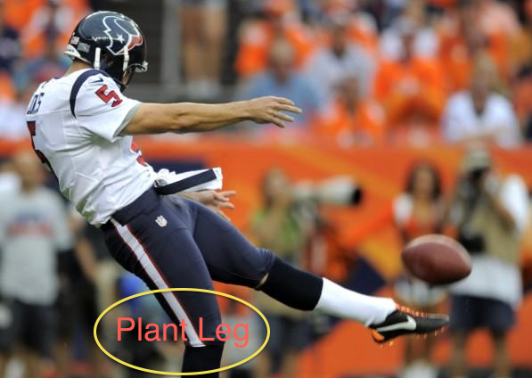Special care is taken in regard to the plant leg, as that is the most defenseless body part of almost any player on the football field. Consider the knee of the plant leg like a car without shock absorbers. With all of the weight of the body on it, it is about as sturdy as a couple of twigs held together by a rubber band. A stray hit there can end a kicker's career almost instantly.

The rulebook gets right to the point in the final note: "When in doubt, it is a foul for roughing the kicker."

**Other Illegal Hits on Players in Compromised Positions**

One of the dirtiest hits in recent memory came on a play that is now illegal. Defenseless players are now protected after a change in possession. Here is Hall of Fame defensive tackle Warren Sapp blowing up Packers offensive tackle Chad Clifton:

At the time, this was legal a football play. Sapp didn't know which direction Clifton would move and whether he might make the eventual tackle, so Sapp played all out until the whistle—just like young players are taught.

It's also clearly a dangerous play, which is now against the rules.

Players are also protected from blows to and from the head during blindside blocks in which an offensive player is moving parallel to the line of scrimmage, as well as illegal crack-back blocks in which the offensive player uses his head. Let's just call this one the "Hines Ward Rule." Here's Seattle Seahawks receiver Golden Tate being called for such an illegal block on Dallas Cowboys linebacker Sean Lee:

In addition, players are protected when they are already on the ground or in the act of sliding; when they are already in the grasp of a tackler or when they are receiving a kick or a punt. Again, it's entirely up to defenders to know all of these rules and to abide by them as the NFL seeks to make the game a safer place.

That, in a nutshell, is the bottom line here. The NFL realizes it is impossible to make the game safe—I don't think Goodell or the owners are that deluded. No, but safer is a possibility as the league attempts to move forward with new rules (along with new technology and new medical advances).

It isn't a popular goal, but it hasn't made the NFL any less popular, either, which means the new rules will persist, the game will continue to evolve, and defenders (and fans) need to take note.

**Michael Schottey is the NFL National Lead Writer for Bleacher Report and a member of the Pro Football Writers of America. Find more of his stuff at**[***The Go Route***](http://bleacherreport.com/thegoroute)**.**

***So to recap***, below are the definitions of a defenceless player and what may not be inflicted on that individual under new ***RULE 7 SECTION 3 ARTICLE 16.***

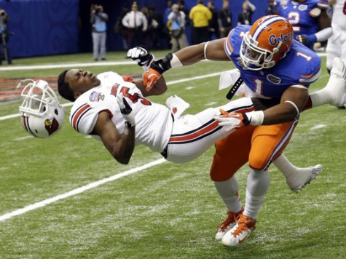

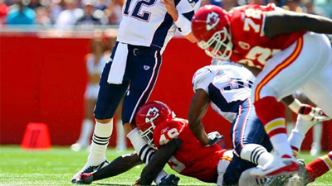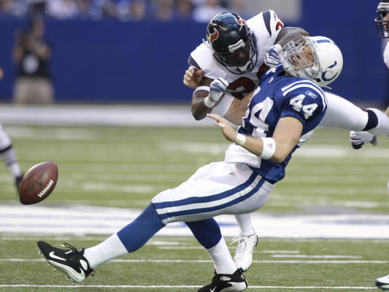

# “Targeting” Defined in *US High School Football* in Effort to Reduce Risk of Injury

In an effort to reduce contact above the shoulders and lessen the risk of injury in high school football, the National Federation of State High School Associations (NFHS) Football Rules Committee developed a definition for “targeting,” which will be penalized as illegal personal contact.

**What is a Defenceless Player?**

**RULE 7 SECTION 3 ARTICLE 16**

1. A player in the act of or just after throwing a pass;
2. A receiver attempting to catch a pass; or who has completed a catch and has not had time to protect himself or has not clearly become a runner. If the receiver/runner is capable of avoiding or warding off the impending contact of an opponent, he is no longer a defenseless player;
3. A runner already in the grasp of a tackler and whose forward progress has been stopped;
4. A runner or punt returner attempting to field a kick in the air;
5. A player on the ground;
6. A kicker/punter during the kick or during the return
7. A quarterback at any time after a change of possession
8. A players who receives a “blindside” block when the blocker is moving toward or parallel to his own end line and approaches the opponent from behind or from the side, and
9. A player who is protected from an illegal crack block B) Prohibited contact against a player who is in a defenseless posture is:

**What you can’t do to a Defenceless Player**

1. Forcibly hitting the defenseless player’s head or neck area with the helmet, facemask, forearm, or shoulder regardless of whether the defensive player also uses his arms to tackle the defenseless player by encircling or grasping him; or
2. Lowering the head and making forcible contact with the top/crown or forehead/“hairline” parts of the helmet against any part of the defenseless player’s body; or
3. Illegally launching into a defenseless opponent. It is an illegal launch if a player (1) leaves both feet prior to contact to spring forward and upward into his opponent, and (2) uses any part of his helmet (including the top/crown or forehead parts) to initiate forcible contact against any part of his opponent’s body. Note: This does not apply to contact against a runner, unless the runner is still considered to be a defenseless players.

Note 1: The provision of (2) do not prohibit incidental contact by the mask or helmet in the course of a conventional tackle or block on an opponent.

Note 2: A player who initiates contact against a defenseless opponent is responsible for avoiding an illegal act.

**Video suggestions from Rob Christian**

Some visuals that might help demonstrate the lack of protection a defenceless player has to take on a hit.

|  |
| --- |
|  |
| <http://www.youtube.com/watch?v=ZbsH3uGmmI8> |
| <http://www.youtube.com/watch?v=Da3QMsT_BY4> |
|  |
| <http://www.youtube.com/watch?v=Pd225oX4pUg> ***(commentators need to learn the rules)*** |
|  |
| <http://www.youtube.com/watch?v=llXLSs9ZbVo> |
|  |
| <http://www.youtube.com/watch?v=khMX_e8MQ-M> |
|  |
| [***http://cfl.ca/video/index/id/80831***](http://cfl.ca/video/index/id/80831) ***(Hamilton Tiger Cat gets hit hard)*** |

**“Targeting” Defined in High School Football in Effort**

**to Reduce Risk of Injury**

**This article is being re-published from the British Columbia Football Officials Association web site. First published on**[**February 25, 2014**](http://www.bcfoa.ca/postname)**.**

BC is in unique situation in that it officiates both Canadian Amateur and US High Schools.

In an effort to reduce contact above the shoulders and lessen the risk of injury in high school football, the National Federation of State High School Associations (NFHS) Football Rules Committee developed a definition for “targeting,” which will be penalized as illegal personal contact.

The definition of targeting and its related penalty were two of 10 rules changes approved by the rules committee at its January 24-26 meeting in Indianapolis. All rules changes were subsequently approved by the NFHS Board of Directors.

Effective with the 2014 high school season, new Rule 2-43 (***American Football Rules Book****)* will read as follows: “Targeting is an act of taking aim and initiating contact to an opponent above the shoulders with the helmet, forearm, hand, fist, elbow or shoulders.”

Bob Colgate, NFHS director of sports and sports medicine and liaison to the Football Rules Committee, said the committee determined – in its continued effort to minimize risk of injury in high school football – that it was important to separate and draw specific attention to this illegal act.

“Taking aim with the helmet, forearm, hand, fist, elbow or shoulders to initiate contact above the shoulders, which goes beyond making a legal tackle, a legal block or playing the ball, will be prohibited,” Colgate said.

A new definition for a “defenseless player” was also added to Rule 2 for risk-minimization purposes. Rule 2-32-16 will read as follows: “A defenseless player is a player who, because of his physical position and focus of concentration, is especially vulnerable to injury.”

In an effort to reduce the risk of injury on kickoffs, the rules committee approved two new requirements in Rule 6-1-3 for the kicking team. First, at least four members of the kicking team must be on each side of the kicker, and, second, other than the kicker, no members of the kicking team may be more than five yards behind the kicking team’s free-kick line.

Rule 6-1-3 also notes that if one player is more than five yards behind the restraining line and any other player kicks the ball, it is a foul. In addition to balancing the kicking team’s formation, the change limits the maximum distance of the run-up for the kicking team.

“The Football Rules Committee’s actions this year reinforce a continued emphasis on minimizing risk within all phases of the game,” said Brad Garrett, assistant executive director of the Oregon School Activities Association and chair of the Football Rules Committee.

In an effort to reduce contact above the shoulders and lessen the risk of injury in high school football, the National Federation of State High School Associations (NFHS) Football Rules Committee developed a definition for “targeting,” which will be penalized as illegal personal contact.

The definition of targeting and its related penalty were two of 10 rules changes approved by the rules committee at its January 24-26 meeting in Indianapolis. All rules changes were subsequently approved by the NFHS Board of Directors.

Effective with the 2014 high school season, new Rule 2-43 will read as follows: “Targeting is an act of taking aim and initiating contact to an opponent above the shoulders with the helmet, forearm, hand, fist, elbow or shoulders.”

“Taking aim with the helmet, forearm, hand, fist, elbow or shoulders to initiate contact above the shoulders, which goes beyond making a legal tackle, a legal block or playing the ball, will be prohibited,” Colgate said.

A new definition for a “defenseless player” was also added to Rule 2 for risk-minimization purposes. Rule 2-32-16 will read as follows: “A defenseless player is a player who, because of his physical position and focus of concentration, is especially vulnerable to injury.”

**As you can read, the National Federation of National High Schools, and Football Canada/CFOA have come to the same decision when it comes to hits to the head on defenceless players.**

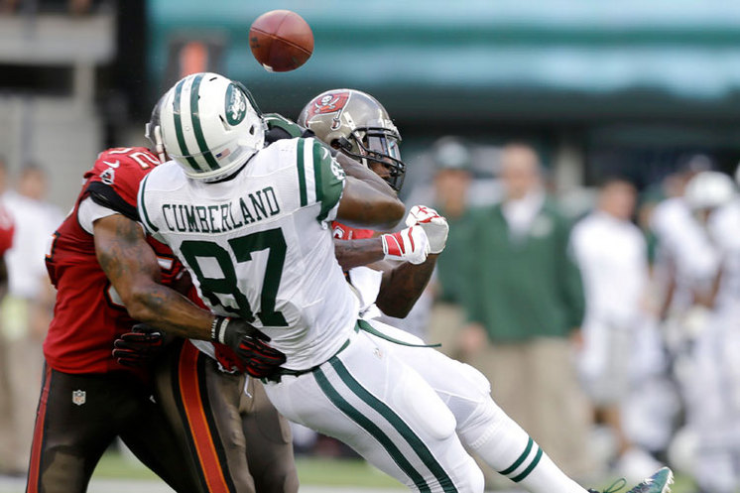

# Facilitator: Official Development : Understanding Rules

Rule changes for 2014

What’s the call?

[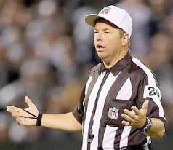](http://www.google.ca/imgres?imgurl=http://www.herefordbrand.com/web/wp-content/uploads/2014/03/Confused-Referee.jpg&imgrefurl=http://www.herefordbrand.com/web/category/sports/page/17/&h=258&w=298&tbnid=VXl3j1aCpi3TWM:&zoom=1&docid=hB1peouMmIP_aM&ei=7zXNU5aHDMKmyASi34LYBQ&tbm=isch&ved=0CCkQMygMMAw&iact=rc&uact=3&dur=1290&page=1&start=0&ndsp=15)

The following quiz was prepared for meeting with coaches by Ardis Oleksyn MFOA VP of recruitment and training

The following “quiz” was compiled a means of encouraging conversation amongst both officials and team/league representatives! **(Remember, Team A is on offense and Team B is the defense.)**

1. On the opening kickoff, the ball lands at the 15 yard line, bounces four times towards the goal line, hits the pylon then rolls out of bounds. Has a point been scored? Where will be the next point of scrimmage?

.

1. The Team A QB scrambles and is brought down cleanly at the opponents 25 yard line, but is injured on the play, and the official stops the clock so that the trainer can attend to the QB. Must the QB leave the game? If so, for how many plays?
2. As the trainer is attending to the injured QB, the Team A coach calls timeout. In this case, must the QB leave the game? If so, for how many plays?
3. Team B linebacker makes a tackle and following the play notices that his chinstrap has broken. He tries to fix it, but cannot and the next play is blown in. The Umpire notices the broken strap, blows his whistle to stop the clock, and tells the LB he must leave the game for repairs to the helmet. Is this correct? If so, how long must the LB remain on the sidelines?
4. The Team A RB runs for 14 yards, and is brought down cleanly. While being tackled, his helmet pops off. The Head Linesman notices this and tells the player he must leave the field for three plays. Correct?
5. On 3rd and 12, the Team A offense remains on the field. The Referee blows his whistle to start both the play clock and the game clock. As the play clock hits 5 seconds remaining, Team A sends on the punt team (ie more than 3 substitutes). The Referee blows his whistle to stop the play and game clocks to allow the substitution. Correct?
6. On the play above, how much time will Team A have to put the ball into play after the play clock is re-started?
7. Same play as #6, but with 5 seconds remaining on the play clock a Team B player takes a knee and requests a trainer. Should the Referee stop the clocks and allow the trainer on the field? If so, how long will Team A have to put the ball into play after the player has been taken from the field? How many plays must the Team B player stay out?
8. Team A WR jumps to catch a pass near the sideline. As he catches the ball he is hit by a Team B player so that he lands on his back out of bounds. The ball pops out when he hits the ground. Complete or incomplete?
9. Team B DT fights off a block, but in the process is knocked to the ground. Once on the ground he rolls into the Team A QB’s legs, who remains in the pocket. Is this a foul?
10. Same play as above, but while on the ground the Team B DT reaches out and grabs the QBs ankle and drags him to the ground. Is this a foul?
11. As the Team A QB scrambles for a gain of 3 yards, a Team B DB dives and tackles him with first contact being at the QB’s knee. Is this a foul?
12. The Team A QB throws a pass, and just as it is thrown, a Team B DE, who is rushing the passer, jumps to block the pass and misses the ball. As the DE comes down he accidentally hits the QB’s head with his arm. Is this a foul?
13. Team A RB breaks through the line and as he tries to avoid a Team B LB, the LB reaches out and grabs the ear hole of the RB’s helmet and drags him down. Is this a foul?
14. Team A SB cuts over the middle on a deep “in” pattern. The pass is a bit high, so he jumps up and extends his arms in an attempt to catch it. Just as the ball hits his hands, the Team B safety arrives and hits him hard in the back with his shoulder. Is this a foul?
15. Team A RB runs for 10 yards, and is then grabbed by three members of Team B and is being held with forward progress stopped. A fourth Team B player runs into the pile and drives his shoulder into the side of the RB’s helmet before the whistle is blown. Is this a foul?
16. As a punt returner is heading up field on the return, the punter moves towards the play to put himself into a position to make a tackle. A player from the return team, in attempting to make a block, lowers his head and drives his helmet into the punter’s shoulder. Is this a foul?
17. Just after the Team A QB throws a pass, a blitzing Team B DB approaches from the QB’s blindside, leads with his shoulder and hits the QB in the ribs. Is this a foul?
18. After intercepting a pass, the Team B safety is retuning the ball towards the Team A end zone. A Team B LB, who is ahead of the return, notices a Team A WR in pursuit of the DB, and turns to make a block on the WR. As the return proceeds, the LB approaches the WR from the side and uses his shoulder to hit the pursuing WR in the helmet. Is this a clean block?
19. Just as a Team A WR catches a pass near the sideline, the covering Team B DB jumps up to make the tackle, driving his shoulder into the WR’s chest. In doing so, the top of the DB’s helmet makes contact with the WR’s facemask. Is there any foul on this play?
20. Team A punts. The ball is bouncing around on the ground and before the Team B punt returner can pick up the ball, the Team A punter runs up and jumps on the ball. At the time of his recovery, another Team A player is three yards from the ball, but is not interfering with the Team B player. Is there a foul on this play?
21. Team A punts. In attempting to field this punt, the ball hits the Team B returner in the chest and falls to the ground. At the time the ball hits his chest two players from Team A are waiting three yards away: one onside player and one offside player. The onside Team A player recovers the loose ball. Is this a legal recovery?
22. On 3rd down and 10, the Team A RB gains seven yards and is tackled. After the whistle has blown a Team B player dives into the RB leading with his helmet. The Referee signals a 15 yard penalty for UR **AND** awards the ball to Team B. Is he correct?
23. On a convert the holder receives the snap with one knee firmly on the ground and immediately pitches the ball to a RB, who runs into the end zone. Have two points been scored?
24. After the game is completed, is it the responsibility of the officials to monitor the post-game handshakes?

What’s the call? SUGGESTED ANSWERS

[](http://www.google.ca/imgres?imgurl=http://www.herefordbrand.com/web/wp-content/uploads/2014/03/Confused-Referee.jpg&imgrefurl=http://www.herefordbrand.com/web/category/sports/page/17/&h=258&w=298&tbnid=VXl3j1aCpi3TWM:&zoom=1&docid=hB1peouMmIP_aM&ei=7zXNU5aHDMKmyASi34LYBQ&tbm=isch&ved=0CCkQMygMMAw&iact=rc&uact=3&dur=1290&page=1&start=0&ndsp=15)

The following “quiz” was compiled a means of encouraging conversation amongst both officials and team/league representatives! **(Remember, Team A is on offense and Team B is the defense.)**

1. On the opening kickoff, the ball lands at the 15 yard line, bounces four times towards the goal line, hits the pylon then rolls out of bounds. Has a point been scored? Where will be the next point of scrimmage?
   * One point has been scored, as the pylon is considered in bounds. After any rouge the next point of scrimmage will be the 35 yard line.
2. The Team A QB scrambles and is brought down cleanly at the opponents 25 yard line, but is injured on the play, and the official stops the clock so that the trainer can attend to the QB. Must the QB leave the game? If so, for how many plays?
   * Yes, for 3 plays in case of injury. Prior to 2014 it was 1 play only.
3. As the trainer is attending to the injured QB, the Team A coach calls timeout. In this case, must the QB leave the game? If so, for how many plays?
   * Yes, for 3 plays. Calling a timeout does not affect this requirement.
4. Team B linebacker makes a tackle and following the play notices that his chinstrap has broken. He tries to fix it, but cannot and the next play is blown in. The Umpire notices the broken strap, blows his whistle to stop the clock, and tells the LB he must leave the game for repairs to the helmet. Is this correct? If so, how long must the LB remain on the sidelines?
   * Yes. He must remain out for at least 1 play in the case of equipment repair.
5. The Team A RB runs for 14 yards, and is brought down cleanly. While being tackled, his helmet pops off. The Head Linesman notices this and tells the player he must leave the field for three plays. Correct?
   * Correct. If the helmet had come off as the result of a foul he would not be required to leave the game.
6. On 3rd and 12, the Team A offense remains on the field. The Referee blows his whistle to start both the play clock and the game clock. As the play clock hits 5 seconds remaining, Team A sends on the punt team (ie more than 3 substitutes). The Referee blows his whistle to stop the play and game clocks to allow the substitution. Correct?
   * Correct.
7. On the play above, how much time will Team A have to put the ball into play after the play clock is re-started?
   * If the clock is stopped for substitution by Team A, the play clock will not be reset. Thus, Team A will have only the 5 seconds remaining on the play clock.
8. Same play as #6, but with 5 seconds remaining on the play clock a Team B player takes a knee and requests a trainer. Should the Referee stop the clocks and allow the trainer on the field? If so, how long will Team A have to put the ball into play after the player has been taken from the field? How many plays must the Team B player stay out?
   * Yes, all indications of injury must be treated as potentially serious. If the clock is stopped for substitution by or injury to Team B, the play clock will be reset. Thus Team A will have the full 20 seconds. The Team B player must remain out for at least 3 plays.
9. Team A WR jumps to catch a pass near the sideline. As he catches the ball he is hit by a Team B player so that he lands on his back out of bounds. The ball pops out when he hits the ground. Complete or incomplete?
   * Incomplete. A receiver must maintain control throughout contact with another player and/or the ground for the pass to be completed.
10. Team B DT fights off a block, but in the process is knocked to the ground. Once on the ground he rolls into the Team A QB’s legs, who remains in the pocket. Is this a foul?
    * Yes. Making forcible contact at or below the knee of a passer who has one or both feet planted is illegal, including rolling into that passer. The foul will be for roughing the passer.
11. Same play as above, but while on the ground the Team B DT reaches out and grabs the QBs ankle and drags him to the ground. Is this a foul?
    * Not a foul. A defender can swipe, wrap or grab a passer in the knee area or below in an attempt to tackle him. But no “forcible” contact is permitted.
12. As the Team A QB scrambles for a gain of 3 yards, a Team B DB dives and tackles him with first contact being at the QB’s knee. Is this a foul?
    * Not a foul. The passer in this situation does not have one or both feet planted, and has essentially made himself a ball carrier. Thus he can be contacted at or below the knee.
13. The Team A QB throws a pass, and just as it is thrown, a Team B DE, who is rushing the passer, jumps to block the pass and misses the ball. As the DE comes down he accidentally hits the QB’s head with his arm. Is this a foul?
    * This will be a discretionary judgment by the Referee. Forcible contact to the head or neck area of the passer is prohibited, so roughing the passer may be called if the Referee feels the contact meets his standard of force. Incidental contact to the head or neck without sufficient force can be ruled as no foul.
14. Team A RB breaks through the line and as he tries to avoid a Team B LB, the LB reaches out and grabs the ear hole of the RB’s helmet and drags him down. Is this a foul?
    * Yes. The definition of face masking has been extended to include grasping the face mask, chin strap or any other helmet opening (ear hole, underneath the helmet, etc.)
15. Team A SB cuts over the middle on a deep “in” pattern. The pass is a bit high, so he jumps up and extends his arms in an attempt to catch it. Just as the ball hits his hands, the Team B safety arrives and hits him hard in the back with his shoulder. Is this a foul?
    * No. Although the Team A receiver meets the definition of a player in a defenseless posture, the contact by the Team B player does not meet the definition of prohibited contact against such a player. In general, prohibited contact is: contact to the defenseless player’s head or neck area; lowering the head and making forcible contact with the helmet to any part of the defenseless player’s body; or launching into a defenseless player’s body and making forcible contact with the helmet.
16. Team A RB runs for 10 yards, and is then grabbed by three members of Team B and is being held with forward progress stopped. A fourth Team B player runs into the pile and drives his shoulder into the side of the RB’s helmet before the whistle is blown. Is this a foul?
    * Yes. The player is in a defenseless posture and the tackler made contact to his head. The foul is unnecessary roughness.
17. As a punt returner is heading up field on the return, the punter moves towards the play to put himself into a position to make a tackle. A player from the return team, in attempting to make a block, lowers his head and drives his helmet into the punter’s shoulder. Is this a foul?
    * Yes. Although the punter can be contacted because he has involved himself in the play, leading with the helmet is illegal. The foul will be spearing.
18. Just after the Team A QB throws a pass, a blitzing Team B DB approaches from the QB’s blindside, leads with his shoulder and hits the QB in the ribs. Is this a foul?
    * No foul. Although the QB meets the definition of being in a defenseless posture, the contact made by the Team B player does not meet the definition of prohibited contact against such a player.
19. After intercepting a pass, the Team B safety is retuning the ball towards the Team A end zone. A Team B LB, who is ahead of the return, notices a Team A WR in pursuit of the DB, and turns to make a block on the WR. As the return proceeds, the LB approaches the WR from the side and uses his shoulder to hit the pursuing WR in the helmet. Is this a clean block?
    * This is a foul. The player is in a defenseless posture, and although the Team B player makes contact from the side, the contact is made forcibly to the head of the defenseless player. The foul will be unnecessary roughness.
20. Just as a Team A WR catches a pass near the sideline, the covering Team B DB jumps up to make the tackle, driving his shoulder into the WR’s chest. In doing so, the top of the DB’s helmet makes contact with the WR’s facemask. Is there any foul on this play?
    * This will be a judgment call by the covering official. As the Team A receiver is in a defenseless posture, forcible contact to his head is prohibited, even in the act of making an otherwise clean tackle. The official will have to determine whether the contact to the head was incidental, or if sufficient force was involved. Remember, this rule is in place to protect players who are put in a position where they cannot protect themselves. It is the responsibility of the player initiating contact against a defenseless player to avoid an illegal act. In all cases, a standard of strict liability applies to a player who initiates contact against a defenseless player, even if the illegal contact is the result of an action of the defenseless player himself, such as ducking his head or curling up his body.
21. Team A punts. The ball is bouncing around on the ground and before the Team B punt returner can pick up the ball, the Team A punter runs up and jumps on the ball. At the time of his recovery, another Team A player is three yards from the ball, but is not interfering with the Team B player. Is there a foul on this play?
    * This is a legal recovery by Team A. No yards can no longer be called against the second Team A player as Team B did not touch the ball.
22. Team A punts. In attempting to field this punt, the ball hits the Team B returner in the chest and falls to the ground. At the time the ball hits his chest two players from Team A are waiting three yards away: one onside player and one offside player. The onside Team A player recovers the loose ball. Is this a legal recovery?
    * This is NOT a legal recovery. At the instant the Team B player touches the ball the offside Team A player must not be within 5 yards of the ball. Therefore, no yards will be called against the Team A offside player and applied from the point the ball was touched by the Team B returner.
23. On 3rd down and 10, the Team A RB gains seven yards and is tackled. After the whistle has blown a Team B player dives into the RB leading with his helmet. The Referee signals a 15 yard penalty for UR **AND** awards the ball to Team B. Is he correct?
    * Correct. The foul occurred in the period following the play (ie it was a dead ball foul). Since yards were not gained, the ball is turned over, and the foul applied at that point.
24. On a convert the holder receives the snap with one knee firmly on the ground and immediately pitches the ball to a RB, who runs into the end zone. Have two points been scored?
    * No. If the holder is going to make a play other than pinning the ball, he must get off his knee first. This play should be blown dead and the convert ruled unsuccessful.
25. After the game is completed, is it the responsibility of the officials to monitor the post-game handshakes?
    * No. Should any official witness any violent/illegal action it would be noted and reported to the proper league authority, but in general the officials’ responsibility to the game ends at the conclusion of the game.



|  |  |  |  |  |  |  |  |
| --- | --- | --- | --- | --- | --- | --- | --- |
| Alan Kirkpatrick | | | President | | | Alan.Kirkpatrick@hamilton.ca | |
| Nigel Busche | | | Vp Recruitment and Training | | | nvbushe@shaw.ca | |
| Ron Hallock | | | Vp Training and Development | | | rhallock@shaw.ca | |
| Barry DeBaie | | | Vp Communication | | | barry.debaie@cdha.nshealth.ca | |
| Ron Paluzzi | | | Vp Finance | | | rpaluzzi@3macs.com | |
| Province | Representative | email | | Province | Representative | | email |
| Nova Scotia | Chad Doran | Doran.chad@gmail.com | | Manitoba | Ardis Oleksyn | | aoleksyn@hotmail.com |
| New Brunswick | Allison Gates | abgates@nb.sympatico.ca | | Saskatchewan | Todd Joyes | | tjoyes@sasktel.net |
| Prince Edward Island | Robert St.Pierre | robert.st-pierre@ssc-spc.gc.ca | | Alberta | Gord Unger | | gord40@mymts.net |
| Quebec | Walter Berry | berry.walter@sympatico.ca | | British Columbia | Bruce Hackshaw | | bhawkshaw@gmail.com |
| Ontario | Murray Taylor | ofoapres@mhte.ca | |  |  | |  |

|  |  |  |  |
| --- | --- | --- | --- |
| Web Committee |  |  |  |
| Dean McNeill | dean.mcneill@ad.umanitoba.ca | Jason Maggio | Maggio@haltronrc.ed.on.ca |
| Shawn Kerr | Shawn.kerr@shaw.ca | Ron Paluzzi | rpaluzzi@3macs.com |
| George Montani | georgem@power.ca | Mike Szcur | mike@szczur.com |
| Bill Pickrell | billpickrell@rogers.com |  |  |
|  |  |  |  |
| Constitution committee |  |  |  |
| chair Bill Pickrell | billpickrell@rogers.com |  |  |



**Football Canada** 100 – 2255, boul. St. Laurent Ottawa, ON K1G 4K3 Telephone : 613-564-0003 Fax: 613-564-6309 info@footballcanada.com

|  |  |
| --- | --- |
| Contacts **Rose-Anne Joly** Administrative Coordinator: | General inquiries admin@footballcanada.com ext: 221 |
| **Shannon Donovan** Executive Director: | Operations, events, competitions, officials, finance operations@footballcanada.com ext: 225 |
| **Aaron Geisler**  Technical Coordinator: | JPD, 6-A-Side, Flag Football, Aboriginal programs, NCCP technical@footballcanada.com ext: 227 |
| **Patrick DeLottinville** | Communications Coordinator  communications@footballcanada.com  ext: 226 |
| Tamara Hinic  Event Coordinator | events@footballcanada.com  ext. 222 |
| Jean François Lefebvre,  Manager, Program Development | development@footballcanada.com  ext. 228 |