First and Ten
August 2016 Volume 10 Issue 8
66666

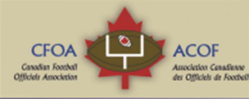
The last issue ?????????????????????
Let here from you
CF?A

First and Ten Mandate | 3
First and Ten Editors | 4
More officials in the development pipeline, as NFL expands training program by Mark Schultzv | 5
Rob’s Corner Float like a butterfly…dodge like a refby Mark Schultz • | 8
Referee PollsArchivehttp://www.referee.com/resources/pollsarchive/?poll_ | 10
Canada Cup 2016 Referee-In-Chief (RIC) Report edited version John Katciuk | 12
IFAF World Championship Football Canada source | 17
Scarborough’s Ken Green marks 60 years of football officiating this season By David Grossman | 20
More CFOA news | 23
CFOA executive | NA
Football Canada | NA
Working for the development of officiating and football in Canada in cooperation with

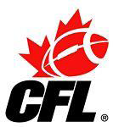
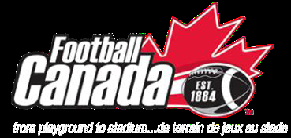
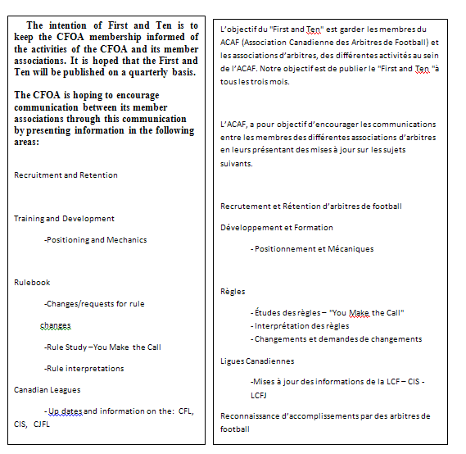

La version française du "First and Ten" va suivre chaque version anglaise. Ron Paluzzi, Vice président responsable de la traduction, sera responsable de s’assurer que chaque communiqué soit disponible en français dans les plus brefs délais. D’ici là, je demande à tous

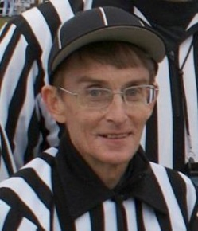
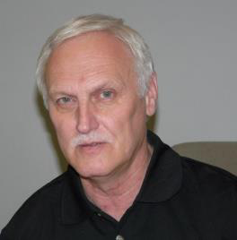
First and Ten Editor Ron Hallock
Co- editor Rob Christian
Do you want or need the CFOA? Why?

That is the question officials will be facing shortly. Why you ask? Let me me explain this rant.
Back in Montreal at the CFOA conference 2006, the CFOA executive at the CFOA AGM resigned in mass. The CFOA was starting to lose its usefulness. The late Michael Groleau and myself set about to round up a new executive and set the direction for the CFOA. Together we drew up a constitution and policy manual which was adopted and modified over the past 19 years to what it is today. We increased participation by introducing provincial representatives and gave the vote to all provinces. We increased monthly communication of the CFOA activities and information to encourage the development of officiating skills. The CFOA worked in cooperation with Football Canada to deliver the national officials certification program and train Master Facilitator (MF) program to train facilitators in facilitating mentoring and goal setting or evaluation. The MF program allowed more participation in local FOAs to provide for better opportunities for official development. The CFOA provide insurance program for FOAs that required it
Football Canada(FC) is launching the official long term development committee. This committee will advise Football Canada as it retakes complete ownership of major areas off officiating at the national level. There will be a revised modular certification program covering both tackle and flag football. A new registration through the Goal line management system will improve registration and monitoring of official development, FC plans to offer insurance to all its registered participants and opportunities to purchase equipment through FC. FC will operate the national certification program as all MF and facilitators are under their roof.
So if these changes occur, what do you need the CFOA for? The new executive decided to survey all the membership requires. An executive member was given this responsibility but to date there has been no report. The executive was going to refresh the website and did do an investigation. At this moment it is cost prohibited,
There was direction given that the newsletter should revolve around reports from the executive and the provincial representatives and include updates on rulings and play situations. To date this has been a very limited source for information. Hence for the next while after 128 issues I will stop the issuing of this document until i receive further direction from you the membership and the CFOA executive. It has been an honour to help provide information and news to the CFOA membership
As closing remark if you want the CFOA to exist or the First and Ten to continue identify your wants by emailing the CFOA executive
henrychiu@outlook.com President
executive

nvbushe@shaw.ca rpaluzzi@3macs.com doran.chad@gmail.com

rhallock@shaw.ca

More officials in the development pipeline, as NFL expands training program

by Mark Schultz • July 27, 2016

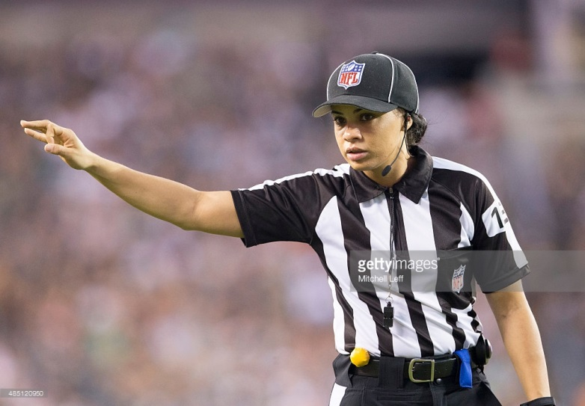
http://www.footballzebras.com/2016/07/27/more-officials-in-the-development-pipeline/
Maia Chaka #136 officiates the game between the Baltimore Ravens and Philadelphia Eagles on August 22, 2015 at Lincoln Financial Field in Philadelphia, Pennsylvania. The Eagles defeated the Ravens 40-17.

August 22, 2015

29 individuals take part in

on-field audition
This year, the NFL has accepted 29 developmental officials in its annual preseason training program, up from the 21 slots open in the previous three seasons the program has been run. This practice squad for officials
development program, instituted after the last collective bargaining agreement with the officials. This season, the Football Operations website refers to the program as the Officiating Development Program, a name that has referred to all of the league’s training initiatives generally; the change in terminology may reflect the fact that 3 Canadian Football League officials are part of the program, in addition to the 29 developmental officials.
These officials will attend preseason clinics, training camps, scrimmages, and crew meetings and have a chance to work preseason games. Once the regular season begins, these college and CFL officials will return to their regular conference or league to officiate. Once a vacancy opens on the NFL roster, one of the 29 college officials could be hired.
At the end of each season, the NFL evaluates each member of the developmental squad and determines if they are ready to be hired into the NFL, if they need another season in the program, or if they are not a good NFL fit. If the official is dropped from the training program, they can continue calling college football. By our count, 6 of last year’s advanced training officials were not asked back for this season (3 were hired by the NFL in May).
This year’s ODP members are listed below. Superscript numbers show the number of years a returning official has been in the league’s training programs.
- Brian Bolinger, Big Ten
- Mike Carr,² Big Ten
- Maia Chaka,³ Conference USA
- Land Clark, Pac-12
- Ryan Dickson,³ Pac-12
- Matt Edwards,² Big Ten
- Marlow Fitzgerald,² Mountain West
- Quentin Givens,² Big 12
- Michael Griffith, American Athletic
- Nate Jones, Conference USA
- Tony Josselyn, SEC
- Jacob Kemp, Mid American
- Terry Killens, American Athletic
- Justin Larrew, Conference USA
- Kevin Mar,³ Mountain West
- Mike Morton,² ACC
- LaShell Nelson, Conference USA
- Justin Nelson, Pac-12
- Lyndon Nixon,³ Big 12
- David Oliver, SEC
- Nicole Randolph, Missouri Valley
- Mearl Robinson,² Pac-12
- Danny Short, Atlantic Coast
- Tab Slaughter, Big 12
- Reggie Smith, Big 12
- Larry Smith, Mid American
- Frank Steratore, Big Ten
- Mark Stewart, Big 12
- Don Willard, Big Ten
- Steve Woods,² Big Ten
Additionally this year, three CFL officials are part of the ODP program:
- Dave Foxcroft
- Justin McInnes
- Dave Hawkshaw
There are three women in the program, Chaka, LaShell Nelson, and Randolph.
NFL officiating has been a family affair for many years. Currently the Steratores, Bergmans and Paganellis have brother combinations on the field. The Colemans, Hochulis and Freemans have father/son combinations on the field. Joining the family affair in the training program this year are Justin Larrew (son of Joe Larrew), Frank Steratore (cousin of Tony and Gene Steratore), Jacob Kemp (brother of Alex Kemp and the son of the late Stan Kemp) and Tab Slaughter (son of former official and current regional supervisor Gary Slaughter).
Fans may huff and puff at this situation, but while the last name may open the door, these sons and brothers will have to earn their spot on the roster and prove they belong each year.
The ODP officials are not members of the NFL Referees Association (the officials’ union) and the NFL cannot hire them mid-season to replace injured, suspended or terminated officials. The ODP officials will wear a regular NFL officials’ uniform and be numbered 136 on up.
Take a good look at these officials this preseason if you have the chance. Some of these zebras are the future of NFL officiating.
Tags:Brian Bolinger CFL Danny Short Dave Foxcroft Dave Hawkshaw David Oliver Don Willard Frank Steratore Jacob Kemp Justin Larrew Justin McInnes Justin Nelson Kevin Mar Land Clark Larry Smith LaShell Nelson Lyndon Nixon Maia Chaka Mark Stewart Marlow Fitzgerald Matt Edwards Mearl Robinson Michael Griffith Mike Carr Mike Morton Nate Jones NFL-CFL Officiating Development Program Nicole Randolph Officiating Development Program Quentin Givens Reggie Smith Ryan Dickson Steve Woods Tab Slaughter Terry Killens Tony Josselyn

Float like a butterfly…dodge like a ref

by Mark Schultz • November 16, 2013

How NFL officials stay out of the way to preserve life and limb
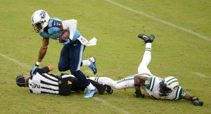
We’ve all seen it. For the fans it is a funny sight but for anyone who has been knocked down by a football player always cringes when a football official gets knocked down. The officials do not wear any padding and when they get trucked by a football player, that bruise and soreness stays with an official for several weeks (video). When an official can see that he will not get out of the way in time and he is going to get knocked down, he gets light on his feet to protect his ankles and knees, and he does his best to tuck and roll. If an official puts his arms out to brace his fall, he runs the risk of breaking his wrists and arms.

Each official has to take different precautions depending on his position. The back judge has to backpedal at the snap and do his best to get to the goal line before any touchdown run. He will move backwards no matter what kind of play it is. The most dangerous play for a deep official is when a receiver runs a pass pattern right at him, when a long play shifts from the sideline to the middle of the field, or when the running back breaks a long one up the middle. The field judge has to wheel out to the side, open up to the play, give the players enough space and pray that the ball carrier doesn’t change direction. If he can’t the results are painful and embarrassing (video).

The deep wings (side judge and back judge) have many of the same considerations as the field judge. They must do their best to get to the goal line. But, unlike the field judge, the deep wings have to consider the traffic on the sideline. Collisions between sideline staff and officials have resulted in serious injuries to both the officials and the people they hit. That is why officials from Pop Warner to the professionals flag sidelines for unsportsmanlike conduct if any coach or non-player is “in the white” during a live ball (video). The head linesman and line judge are responsible for marking the out-of-bounds spot, no matter how long the play. So when a player is run out-of-bounds, the deep wings can keep backing up and getting out of the way and not have to worry about stepping toward the play and putting their foot down at the spot.

For the line judge and the head linesman they must be careful during sweeps to the sideline. When a sweep goes to the sideline, watch those two officials. They will slide step into the backfield and “go against the grain” of the play. Why? Watch where the ball carrier and blockers go crashing out of bounds — many times it will be at the spot the official just vacated. If the official can’t get out of the way, or it turns into a broken play, the official runs the risk of being tackled along with the ball carrie.

Once the head linesman and line judge let the sweep pass them by, they turn up field, watch the ball carrier and mark the progress spot. While the official chases the play up the sideline, they must also watch out for blocked players falling out of bounds. Those blocked players can take an officials’ legs out from under him line a bowling pin.

The NFL umpire gets to officiate for 53 minutes in relative safety — in the offensive backfield across from the referee (7man mechanics). Before the 2010 change that moved him into the offensive backfield, the umpire was in the most dangerous and exposed position on the field — 10 to 12 yards in the defensive backfield with the linebackers (video). In 2009, the NFL logged the umpire position getting knocked to the ground over 200 times during the season. The umpire now only moves into the defensive backfield during the last two minutes of the first half and the last five minutes of the second half (NFL); however during those seven minutes he must be vigilant. From the defensive backfield, the umpire must avoid receivers using them as a pick on pass plays. On running plays he must quickly move if a running lane opens up and he’s in the middle of it. Most umpires have played as interior lineman at some level of organized football, so they have good instincts to read the play.

The referee, from start to finish, is in relatively the safest place on the field. The referee starts out deep and wide of the action and has plenty of time to react and get out-of-the-way if the quarterback scrambles his way. The most dangerous time for a referee is on a long punt, fumble, or interception return. The entire play is busted, and everyone is doing something out of the ordinary. When the play runs in reverse, the referee has to set himself up out-of-the-way of the play and yet close enough to make any rulings. If the play changes direction, he must quickly adjust to the change to again get out-of-the-way yet be close enough to make a call.

Pete Morelli did a great job at this during a recent long return (video).
Officials are part of the playing field. If there is a collision the official not only faces weeks of pain, but he also faces the wrath of the player who collided with him. That player will blame the official (rightly or wrongly) for getting in his way and preventing him from making a play. In over 100 years of organized football, the officials have come up with excellent mechanics so they can be close enough to call the play and yet be at a safe distance; however, try as they might, there are some unfortunate moments for every official in his career where he will make the blooper reel

Referee Polls Archive

http://www.referee.com/resources/pollsarchive/?poll_
Do you display officiating memorabilia?
- Yes (69%, 41 Votes)
- No (31%, 18 Votes)

After officiating a game, what aches?
- Feet (30%, 35 Votes)
- Ankles (10%, 12 Votes)
- Knees (37%, 42 Votes)
- Back (9%, 10 Votes)
- Neck (1%, 1 Votes)
- Other (4%, 5 Votes)
- All of the above (9%, 10 Votes)
When is the last time you bought officiating shoes?
- This Year (63%, 77 Votes)
- 2 Years Ago (25%, 30 Votes)
- 3 Years Ago (7%, 8 Votes)
- 4 Years Ago (2%, 2 Votes)
- 5 Plus Years (3%, 5 Votes)
As a fan, have you ever heckled an official?
- Yes (55%, 39 Votes)
- No (45%, 32 Votes)
Have you ever publicly criticized another official?
- Yes (30%, 24 Votes)
- No (70%, 56 Votes)
Who rates you?
- Coaches (51%, 30 Votes)
- State Association (12%, 7 Votes)
- Local Association (31%, 18 Votes)
- No One (6%, 4 Votes)
What sport is most challenging to officiate?
- Basketball (46%, 98 Votes)
- Soccer (9%, 20 Votes)
- Baseball (8%, 17 Votes)
- Softball (0%, 0 Votes)
- Volleyball (3%, 6 Votes)
- Football (12%, 25 Votes)
- Hockey (22%, 48 Votes)
Do you post officiating-related stuff on social media?
- Yes (32%, 34 Votes)
- No (68%, 71 Votes)
What sport would you next expect to appear in Referee magazine?
- Lacrosse (41%, 21 Votes)
- Hockey (33%, 17 Votes)
- Wrestling (16%, 8 Votes)
- Gymnastics (2%, 1 Votes)
- Tennis (2%, 1 Votes)
- Water Polo (6%, 3 Votes)
Who has a tougher job?
- On-field Official (92%, 47 Votes)
- Replay official (8%, 4 Votes)
For the remaining po;; questions and responses go to the link provided
http://www.referee.com/resources/pollsarchive/?poll_page=2

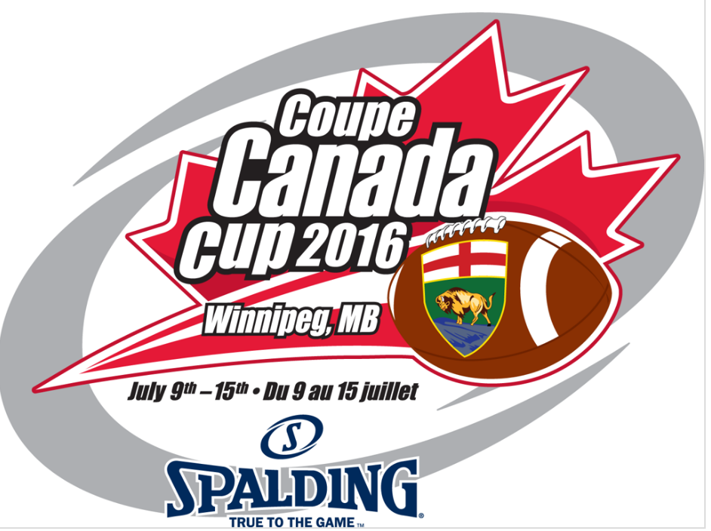

Canada Cup 2016 Referee-In-Chief (RIC) Report
This article contains highlights from the RIC report by John Kachiuk
This report on Canada Cup 2016 provides a consolidated view from the officiating team comprised of the co-Referees in Chief (co-RICs) sponsored officials from the respective provinces of the competing teams as well as the members of the Manitoba Football Officials Association (MFOA).
A great deal of effort was put into making CC 2016 a great success and all of those individuals and organizations involved with this effort are to be commended.
- Football Canada;
- The respective PSOs;
- FOAs of the respective officials;
- Football Manitoba
- Host Committee
- MFOA (special mention for their outstanding efforts in looking after the officials)
The tournament was held at Investors’ Group field home of the Winnipeg Blue Bombers and Manitoba Bison’s at the University of Manitoba for the opening and medal rounds. The middle round was played at the East side Eagles field.
Training s for session’s officials included a seven official’s mechanic session on the Friday prior to the start of the tournament. The two training sessions on off days included a session on building crew dynamics and leadership skills and a presentation by CFL official Steve Dolyniuk on game day preparation.
Video sessions were also held using the Hudl system for review of the games from the first two rounds with all officials involved in active discussion of the plays and fouls. All officials were provide with download links to all games in all three rounds for their own review and for training source for their FOAs
Additional Video Coverage Specific to Officials: The MFOA have one of their members (Garrett Rusnak Grusnak54@gmail.com) who works in the film industry and provides a specialized officiating video support to certain MFOA games.. He videos the game from an officials’ perspective in an attempt to provide video feedback that is more pertinent to the officials. He is in contact with the Game Day supervisor (in our case the RICs) and selected plays can be tagged during the game.
Immediately after the game, a computer and projector are set up in the dressing room in order that the tagged plays can be reviewed by the crew. The intent again is not to punish or belittle anyone, but to attempt to see the play while it is still fresh in everyone’s mind, review the positives to hopefully be continually applied and also look at the negatives or questionable issues in order that corrective action can be taken for improved/quality calls as the tournament progresses and also to increase the degree of consistency of calls.
Social Activities were arranged for the out of town officials by MFOA. The schedule provided out of town officials an opportunity to see some of Winnipeg and its features as well as providing a forum for developing camaraderie amongst the officials. A large vote of thanks is extended to the MFOA organizing committee for setting up and executing the program. Their efforts were greatly appreciated by all.

Canada Cup 2016 Officiating Team

Sponsored officials In Town Officials
- Eric Leblanc (NB) Daniel Doerksen Damien Lacasse
- Omar Kment (Quebec) Mark Schmidtke David Kendall
- Jayden Robertson (ON) Art McAvoy Michael Klassen
- Adam Lawlor (NS) John Paul Chorney Ian Fergusson
- Rod Hazen (SK) Jamie Bernard James Cowtun
- Hassan Cohen (AB) Kyle Mikulik David Wegner
- Ardis Oleksyn (MB) Ryan Ratte
- Christopher Donaldson (MB) Grant Wuckert

Timers and Sticks
- Cheryl Kostelnyk Darryl Scott Alvin Semenek
- Brian Hlatkey Doug Fraser Doug Fraser
- Doug Fraser Floyd Bergner Steve Christenson
- Scott Olafson Don Van Achte Scott Wegner
- Stephen Blaine Gilles Lamontagne Cameron Fortier
- Derek Spottar Donna Beauchamp Ed Bell
- Kevin Sadowy Kelly Semenko Bernie Novak

RICs
- Ron Hallock (In Province) John Kachuik (Out of Province)

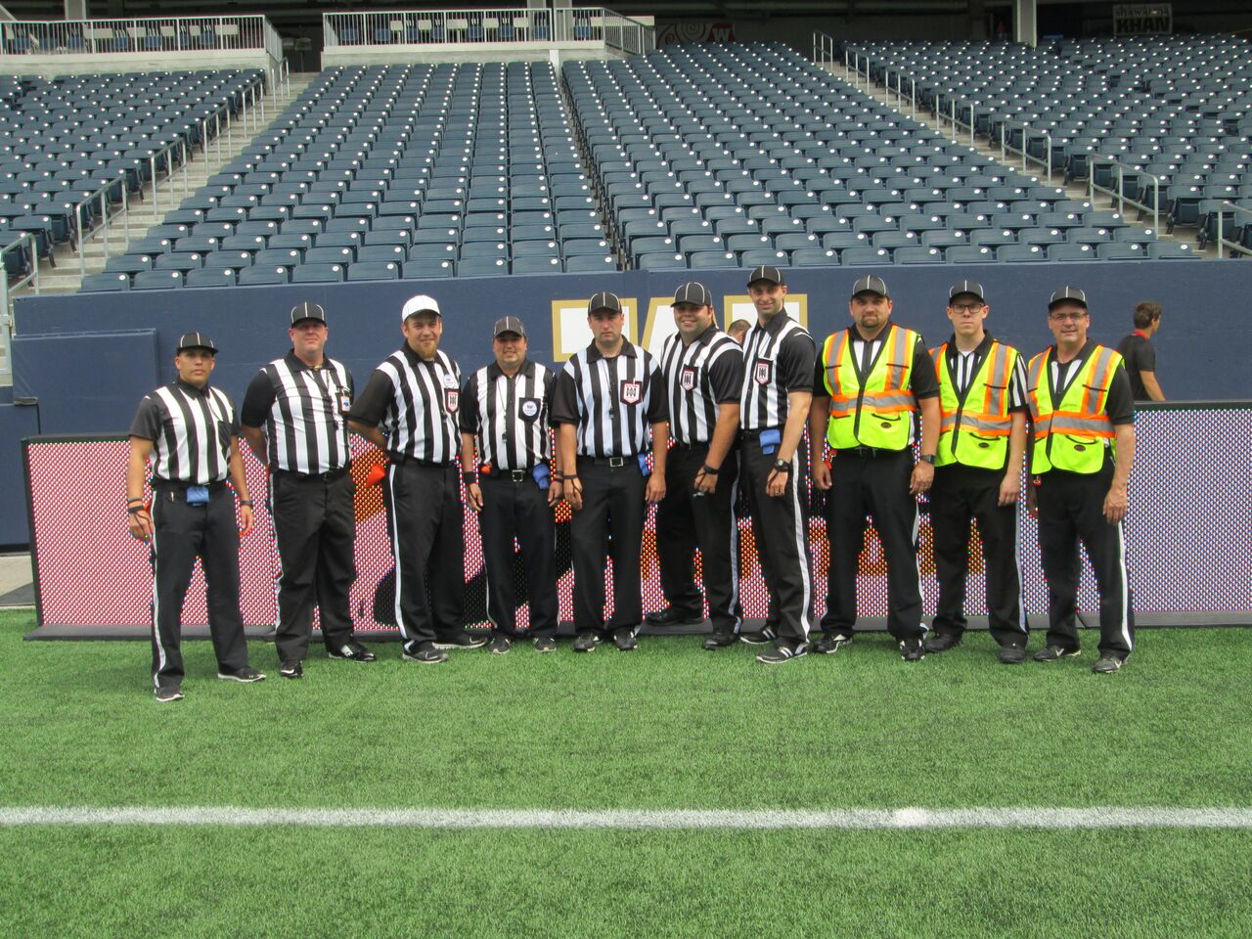
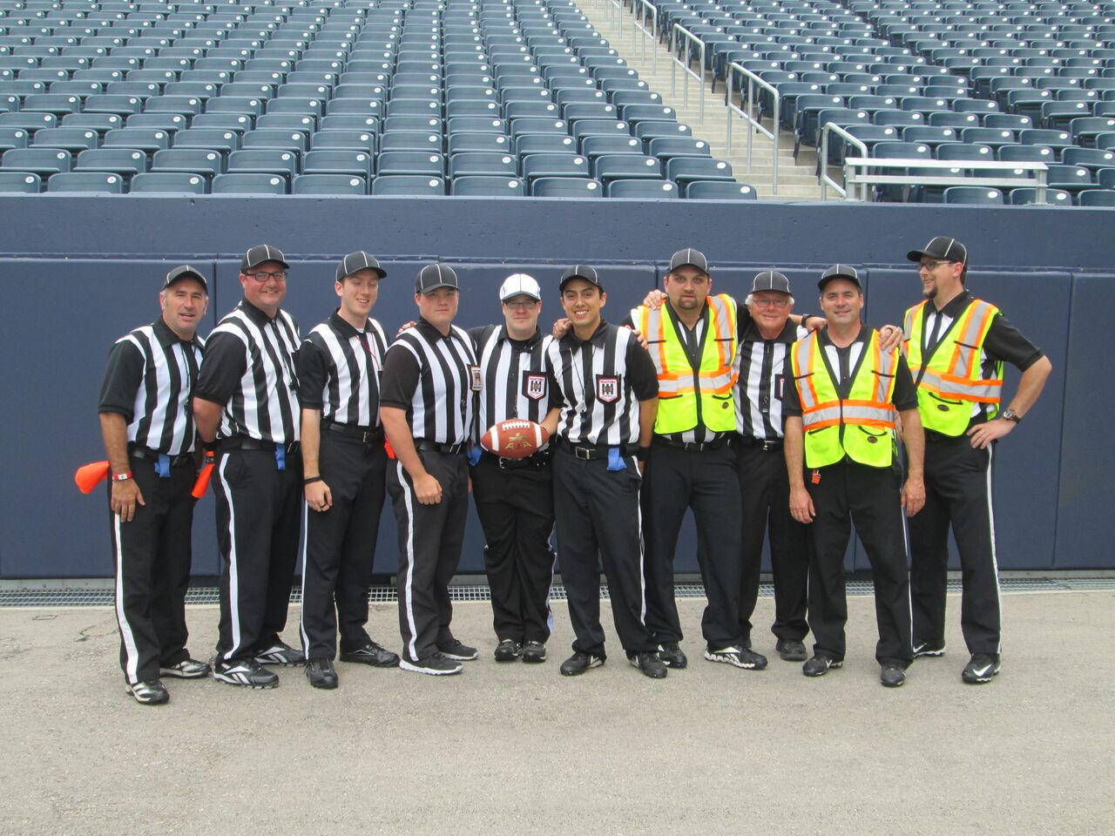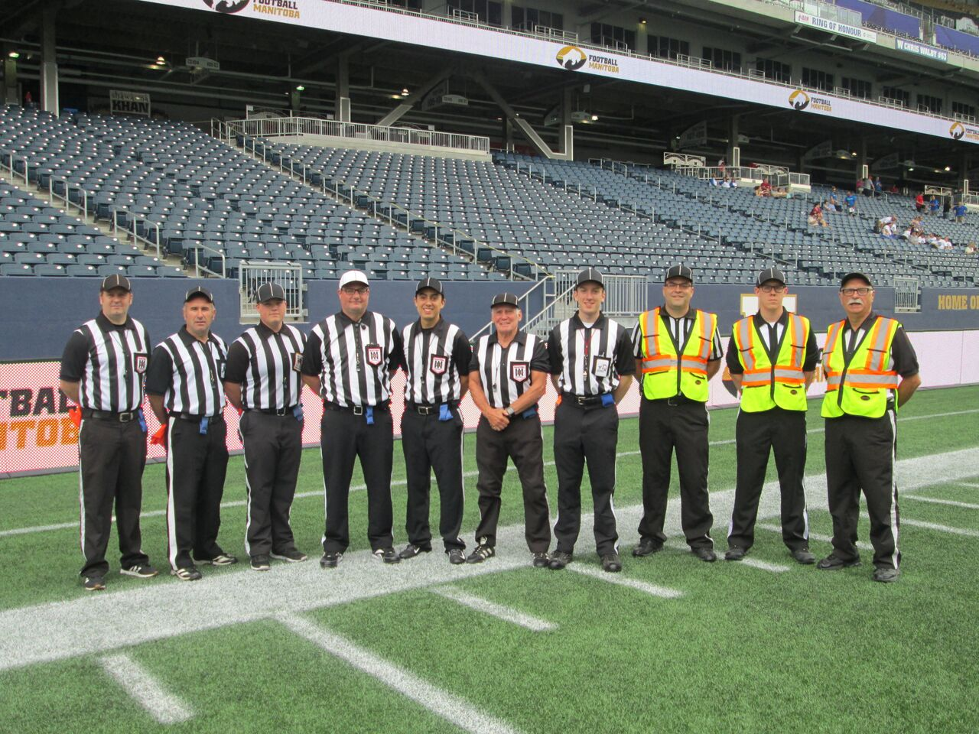

Final Round Assignments
Game 9 11AM |  |  |  |  | Game 10 2PM
New Brunswick and Manitoba Silver |  |  |  |  | Manitoba Gold vs Nova Scotia
Referee | Chorney |  |  |  | Referee | Ratte
Umpire | Mikulik |  |  |  | Umpire | Doerksen
Head linesman | Leblanc |  |  |  | Head linesman | Bernard
Line Judge | Schmidke |  |  |  | Line Judge | Hazen
Side Judge | Lawlor |  |  |  | Side Judge | Cohen
Back Judge | Kment |  |  |  | Back Judge | Robertson
Field Judge | Olekysn |  |  |  | Field Judge | Donaldson
Game 11 5 PM |  |  |  |  | Game 12 Quebec vs Saskatchewan
Alberta vs Ontario
Referee | Olekysn |  |  |  | Referee | Donaldson
Umpire | Mikulik |  |  |  | Umpire | Doerksen
Head linesman | Leblanc |  |  |  | Head linesman | Hazen
Line Judge | Lawlor |  |  |  | Line Judge | Fergusson
Side Judge | Klassen |  |  |  | Side Judge | Cowtun
Back Judge | Kment |  |  |  | Back Judge | Cohen
Field Judge | McAvoy |  |  |  | Field Judge | Robertson

Congratulations to the following officials whose performance at the Canada Cup earned them nominations to the 2017 International Bowl in Texas

Chris Donaldson Manitoba Football Officials Association
Jayden Robertson Eastern Ontario Tackle Football Association
Hassan Cohen Calgary Football officials Assocition

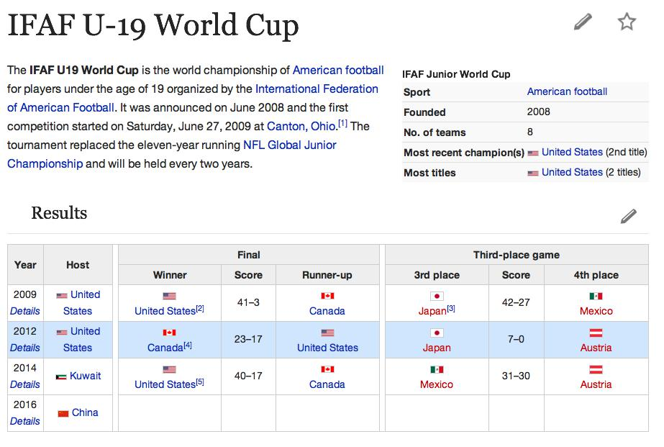
Founded in 1952, Harbin University of Commerce is the first multidisciplinary commerce-oriented university in China. It is one of the key universities in Heilongjiang Province.
It is located in Harbin, a famous northern city in China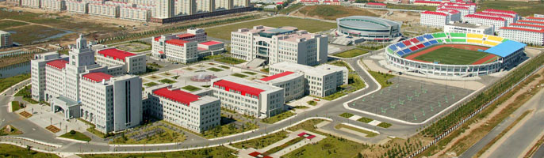
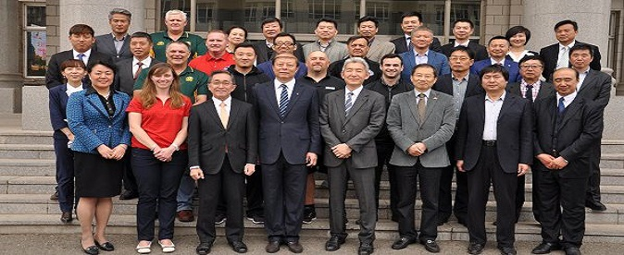
First Row second from left Football Canada Executive Director Shannon Donovan attends organizational meetings of IFAF

Game Officials
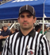
The three officials selected at the 2015 Canada Cup were nominated for the World championship panel . All three officials were invited to officiate
Brandon Iwanyshyn - (Edmonton), and Lauren
DuBreuil - (Quebec)
Accepted invitations and will participate.

The third official Troy Semenchuk - (Saskatchewan) opted for CFL officiating tryout and declined the invitatin
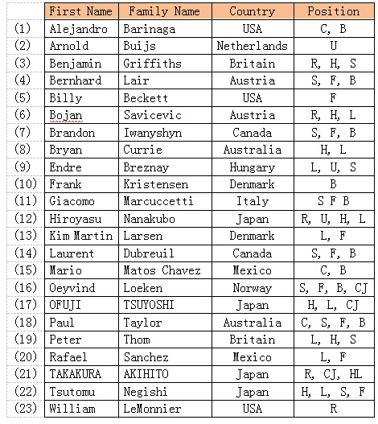
Official Roster

Scarborough’s Ken Green marks 60 years of football officiating this season

http://www.insidetoronto.com/news-story/6759200-scarborough-s-ken-green-marks-60-years-of-football-officiating-this-season/

submitted by John Kachiuk EOTFOA

Green served as CFL’s supervisor of officials for 12 years, worked numerous Vanier Cups
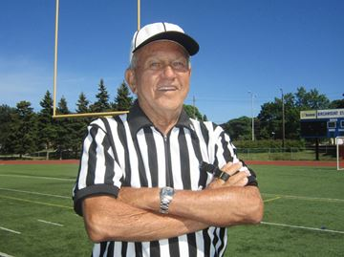

Ken Green
David Grossman/Photo
Scarborough's Ken Green, 80, celebrates 60 years of refereeing football this season. He first started as a football official back in 1956.
Scarborough Mirror
By David Grossman
It has been a very long time, but Ken Green remembers it all.
Back in his second year of studies at the University of Toronto, and admitting to being bored from afternoons without classes, Green made a decision – and it was one that would have an enormous impact on him for decades.
Green chose to respond to a 1956 newspaper advertisement looking for football officials and the Scarborough resident thought he would try “something different”. That is, assuming he was good enough to get hired.
“I remember the ad – they wanted bodies to officiate and I figured it was something to offset the boredom of nothing to do after classes,” recalled Green. “I never played the game and I actually think they didn’t care about qualifications. But I had to learn quickly and have been at it ever since – a long time.”
Fast forward and Green, with quite the legacy and now in his 60th year as a football official, is the only person in Canada doing the job for such an extensive period.
Retirement is close by and Green, who will celebrate his 80th birthday in August with his wife Etty and family, has made the decision to put away his black and white stripe jersey at the end of this year’s football season in November.
Green remembers earning $5 to officiate an amateur football game. Now, the figure has jumped to over $100 for a doubleheader. Treating it as a leisure activity back then, he focused on earning a degree and went on to teach mathematics as well as physical and health education for a 35 years.
“Officiating was a hobby back then, and little did I know that I would one day become Referee-in-Chief of University football, do Vanier Cups and everything from high school to club and more. I can’t complain with what I’ve accomplished.”
Having blown whistles and thrown penalty flags at thousands of games, Green still finds time to be a mentor and is the recipient of almost every major award offered to a football official in the country.
Green never did get an opportunity to officiate in the Canadian Football League, saying only that “internal politics” may have been a factor, but carries no grudge and was the supervisor of CFL officials for 12 years.
In 1990, Green received the Tom Cheney award, the highest award given by Canadian amateur officials. Now, the Ken Green Trophy also exists and is awarded to an outstanding official in Ontario. Chatter in the sport community has Green lined up to be honored among the next wave of inductees to the Canadian Football Hall of Fame.
Being a football official, also came with its fair share of controversy – including nasty comments from spectators and coaches. Only once did he eject a coach.
“You rely on judgment and the rules,” said Green.
“Sure I’ve made several mistakes and admit to it. If someone comments about officiating, that’s fine. You tend to ignore it. But when they get mean, vicious and personal and direct it at you – that’s when I throw the flag. You can only tolerate so much.”
Green soaks up the personal pride and said the ultimate compliment comes when coaches tell him they’re happy he’s doing their game.
“The secrets of success in football – it comes down to having an understanding wife,” said Green.
“During the football season, there is always a game somewhere and I have spent many hours away from home. Yet, there have been no complaints from my wife. Next to my family and teaching, football has been the most important thing in my life.”
Asked if there were highlight moments, Green talks about being asked to officiate the 1979 Can Am Bowl match-up of U.S. and Canadian university all-stars. Ten years later, he did his last university game — a 35-10 win by Western over Saskatchewan in the Vanier Cup played in front of a crowd of 32,847 at SkyDome.
“Looking back, it’s humbling – and like a dream,” said Green. “I’ll never be able to give back to football what it gave to me.”

13th annual Burlington Sport Alliance Award Gala Official of the Year Award
At the 13th annual Burlington Sport Alliance Award Gala this evening, veteran Lakeshore FOA official, Ron 'Skinny' MacVinnie, was presented the Official of the Year Award - a well-deserved recognition for Skinny's contribution on and off the field.

MFOA life member remembered
Richard Bevan recently passed away. Richard was a former president of the MFOA and life member. Richard also co-chaired one of the CFOA conferences that the MFOA hosted.

