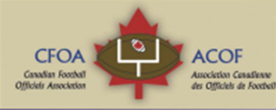
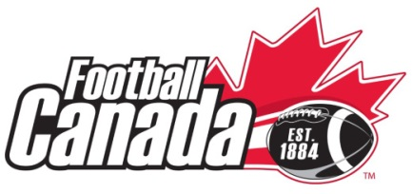
Co Referee In Chief
2017 Western Challenge
Expression of Interest

The 2017 Football Canada U16 Western Challenge will take place at University of Lethbridge in Lethbridge, Alta from July 1-7, 2017. The challenge will feature a field of four provincial teams from Saskatchewan, Manitoba, British Columbia, and host Alberta.
The CFOA has the responsibility of recommending suitable candidates to Football Canada for these positions. The duties and required qualifications are presented here.

Duties of the Co Referee in Chief
- Arranges for necessary number of qualified officials for each game
- Provinces to submit officials names and coordinates prior to tournament.
- Must attend the Team General Manager’s meeting (upon day of arrival) and advise the group of any rule changes to the Canadian Amateur Rule Book for Tackle Football for that year. The Referee-in-Chief must also review with the group the special rules and regulations in the Technical Information Package.
- Prime liaison between Football Canada, Football Canada Cup Host Organizing Committee and officials.
- Supervisor at all games and responsible for all game officiating concerns
- Review FC U16 Regional Challenge rules and procedures
- Supervise and evaluate officials providing feedback
- Attend GM meetings
- Should convene mid tournament meeting and a meeting prior to championship game with officials. (note format is now to arrange for training sessions and video review on off days)
- File written report with the CFOA on feedback on officials and event overall. CFOA to make copy available for Football Canada after reviewed.
- In conjunction with local assignor will select officials for games
- Game tape will be made available for RIC’s to use for review with officials

Qualifications
- Should have experience officiating and supervision/evaluation of officials at the high school level and/or higher.
- Should be certified as Evaluator under the new FCOCP facilitator program
- Have organizational skills to arrange for or conduct training sessions
- Experience at analyzing official performance from game tapes and conducting video review sessions.
Please complete the following information form and return to Nigel Bushe, VP CFOA no later than March 31.
The CFOA executive will select candidates for the positions and forward the name to Football Canada for approval. The selected candidates will be notified by football Canada in early April. (Candidate selected is not limited to those who expressed interest)
Please note there is no remuneration for this position. RIC’s selected will have flight, accommodations, and food requirements covered. Accommodation will be either at a residence on the campus of the host or at a nearby hotel.

Co Referee In Chief
2017 Western Regional Championship
Expression of Interest
Information sheet
Return to nigel.bushe@rcmp-grc.gc.ca by Noon March 31, 2017
Name:
Date of birth: Gender: M F
Home address:

E-mail address:
Telephone: (xxx-xxx-xxxx)
Emergency Contact & Phone:
Cell phone
Provincial Officials Association:
Number of years as an official: Current Level:

On Field Highlights (National Championship games/playoff games)

National Certification program FCOCP (place x in blank) if certified as
___ Master Facilitator
____ Facilitator
___clinician
___mentor
___evaluator
Experience (years and levels) as a(n):
Assignor
Supervision /evaluator
Video performance analysis

