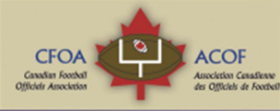
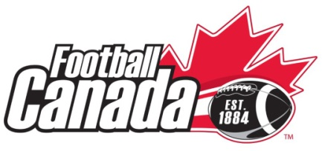
Out of Province Referee In Chief
2017 Canada Cup
Expression of Interest

Eight provincial teams will compete for the under-18 tackle football national championship, the Football Canada Cup, at Raymond Field in Wolfville, NS from July 8-14, 2017. The 2017 edition will feature a field of eight provincial teams from Alberta, British Columbia, Saskatchewan, Manitoba, Ontario, Quebec, New Brunswick, and host Nova Scotia.
The CFOA has the responsibility of recommending a suitable candidate to Football Canada for this position. The duties and required qualifications are presented here.

Duties of the Out of Province Referee
- Arranges for necessary number of qualified officials for each game
- Provinces to submit officials names and coordinates prior to tournament.
- Must attend the Team General Manager’s meeting (upon day of arrival) and advise the group of any rule changes to the Canadian Amateur Rule Book for Tackle Football for that year. The Referee-in-Chief must also review with the group the special rules and regulations in the Technical Information Package.
- Prime liaison between Football Canada, Football Canada Cup Host Organizing Committee and officials.
- Supervisor at all games and responsible for all game officiating concerns
- Review FCC rules and procedures
- Supervise and evaluate officials providing feedback
- Attend GM meetings
- Should convene mid tournament meeting and a meeting prior to championship game with officials. (note format is now to arrange for training sessions and video review on off days )
- File written report with the CFOA on feedback on officials and event overall. CFOA to make copy available for Football Canada after reviewed.
- In conjunction with local assignor will select officials for championship games
- Game tape will be made available for RIC to use for review with officials

Qualifications
- Should have experience officiating and supervision/evaluation of officials at the high school level and higher.
- Should be certified as Evaluator under the new FCOCP facilitator program
- Have organizational skills to arrange for or conduct training sessions
- Experience at analyzing official performance from game tapes and conducting video review sessions.
Please complete the following information form and return to Chad Doran, CFOA VP of Communication no later than March 31 2017.
The CFOA executive will select a candidate for the position and forward the name to Football Canada for approval. The selected candidate will be notified by football Canada in early April. (Candidate selected is not limited to those who expressed interest)
Please note there is no remuneration for this position. RIC selected will have flight, accommodations, and food requirements covered. Accommodation will be either at a residence on the campus of the host or at a nearby hotel.

Out of Province Referee In Chief
2017 Canada Cup
Expression of Interest
Information sheet
Return to doran.chad@gmail.com by Noon March 31, 2017
Name:
Date of birth: Gender: M F
Home address:

E-mail address:
Telephone: (xxx-xxx-xxxx)
Emergency Contact & Phone:
Cell phone
Provincial Officials Association:
Number of years as an official: Current Level:
On Field Highlights (National Championship games/playoff games)

National Certification program FCOCP (place x in blank) if certified as
___ Master Facilitator
____ Facilitator
___clinician
___mentor
___evaluator
Experience (years and levels) as a(n):
Assignor
Supervision /evaluator
Video performance analysis

